Dissertation Title

Lung Cancer Detection Using CT Scan Image Segmentation and Classification using Image Processing

Final Thesis

In Partial Fulfillment
of the Requirements for the Degree of
Master in Computer Science

Student Name | : | Vinod Kumar Gopidesi
Student ID | : | 2826749
Supervisor | : | Shaheen Khatoon

Abstract

Lung cancer is one of the most dangerous diseases in the world, and early detection is very important to improve patient survival. In this study, a deep learning based approach is proposed for lung cancer detection using CT scan images with the help of image segmentation and classification techniques. The dataset used in this work is the IQ-OTHNCCD lung cancer dataset, which contains three classes such as normal, benign, and malignant cases. The dataset is preprocessed, augmented, and splitted into training, validation, and testing sets to ensure better learning of the models. Some imbalance is also present in the dataset, so class weighting and augmentation techniques are applied to reduce this issue and improve model performance.

In this work, three different models are implemented, including a custom CNN model, MobileNetV2, and VGG16. These models are trained using transfer learning and deep learning techniques. The performance of each model is evaluated using metrics such as accuracy, precision, recall, and F1-score. Among all the models, MobileNetV2 achieved the best performance with accuracy of 0.818, precision of 0.800, recall of 0.790, and F1-score of 0.795, which shows that it can classify lung cancer images more effectively. Also, VGG16 performed as second best model with accuracy of 0.813, precision of 0.788, recall of 0.863, and F1-score of 0.824, indicating strong capability in identifying malignant cases even when data variations are present.

The custom CNN model showed comparatively lower performance due to its limited depth and feature extraction capability. However, it still provides a baseline for comparison and understanding of deep learning models. The results clearly shows that transfer learning based models performs better than traditional CNN models in medical image classification tasks. The confusion matrix and performance metrics also indicates that the models are able to distinguish between different lung conditions with reasonable accuracy, but still some misclassification is present.

Overall, this study demonstrates that deep learning models can be effectively used for automated lung cancer detection. The proposed approach helps in reducing manual effort and can assist medical professionals in faster diagnosis. However, the model performance can be further improved by using larger datasets and more advanced architectures, which is important for real world medical applications.

Keywords: Lung Cancer Detection, CT Scan Images, Deep Learning, Image Segmentation, MobileNetV2, VGG16

Acknowledgements

Table of Contents

Table of Contents
Abstract ii
List of Tables viii
List of Figures ix
List of Acronyms x
Chapter 1 Introduction 11
1.1 Background 14
1.2 Problem Statement 15
1.3 Research Question and Objectives 16
1.4 Expected Outcomes 17
Chapter 2 Literature Review 19
2.1 Early Research on Automated Lung Cancer Detection 19
2.2 Deep Learning Models for Lung Cancer Classification 20
2.3 Hybrid Machine Learning and Segmentation Approaches 22
2.4 Advanced Deep Learning Architectures for CT Image Analysis 23
2.5 Recent Innovations in Deep Learning Based Cancer Detection 24
2.6 Explainable Artificial Intelligence and Future Research Directions 25
2.7 Literature Review Summary 26
Chapter 3 Methodology 29
3.1 Research Design 29
3.2 Research Framework 30
3.2.1 Data Collection 31
3.2.2 Data Preprocessing 33
3.2.3 Data Augmentation 35
3.2.4 Feature Extraction 36
3.2.5 Model Development 38
3.2.5.1 Convolutional Neural Network (CNN) 38
3.2.5.2 Transfer Learning Models 39
3.2.5.3 ResNet50 39
3.2.5.4 MobileNetV2 40
3.2.5.5 VGG16 40
3.2.6 Model Training 40
3.2.7 Evaluation 41
3.3 Ethical Considerations 43
Chapter 4 Implementation 45
4.1 Dataset Acquisition and Organization 45
4.2 Data Preprocessing, Augmentation and Splitting 47
4.3 Model Building using MobileNetV2 48
4.4 Model Evaluation and Prediction 49
4.5 Model Development 50
Chapter 5 Result Analysis 54
5.1 Results 55
5.1.1 Accuracy & Loss Curves Analysis 55
5.1.2 Confusion matrix analysis 61
5.1.3 Evalution Metrics 64
5.1.5 Comparison 66
Chapter 6 Conclusion 71
6.1 Conclusion 71
6.2 Future Enhancement 72
Reference 74

List of Tables
Table 1. Literature Review Summary 27
Table 2 . Comparison Model…………………………………………………67

List of Figures
Figure 1 Sample Image Visualization 44
Figure 2 Dataset Acquisition and Organization 44
Figure 3 Data Preprocessing, Augmentation and Splitting 46
Figure 4 Model Building using MobileNetV2 47
Figure 5 Model Evaluation and Prediction 48
Figure 6 MobileNetV2 Model 49
Figure 7 VGG16 Model 49
Figure 8 CNN Model 51
Figure 9 Accuracy Curve-MobileNet50 54
Figure 10 Loss MobileNet50 Model 55
Figure 11 Accuracy and Loss Curve VGG16 Model 57
Figure 12 Accuracy and loss CNN Model 59
Figure 13 MobileNetV2 Model 60
Figure 14 VGG16 Model 61
Figure 15 CNN Model 62
Figure 23 Accuracy Comparison 65
Figure 24 Precision Comparison 66
Figure 25 Recall Comparison 67
Figure 26 F1 Score Comparison 68

List of Acronyms

Chapter 1 Introduction

Lung cancer is one of the most serious and life threatening diseases in the world today. It affects millions of people every year and remains one of the leading causes of cancer related deaths globally. Lung cancer mainly develops when abnormal cells grow uncontrollably in the lung tissues and form tumors that can interfere with normal breathing and oxygen exchange. If the disease is not detected at an early stage, it can spread to other parts of the body and become very difficult to treat. Many factors such as smoking, air pollution, genetic conditions, and exposure to harmful chemicals are considered major risk factors for lung cancer. Because of these reasons, early detection of lung cancer is extremely important to improve treatment outcomes and increase the survival rate of patients (World Health Organization, 2021).

Medical imaging techniques play a very important role in the diagnosis of lung cancer. Among the different imaging methods, Computed Tomography (CT) scans are widely used for examining lung structures and identifying abnormal tissues or nodules inside the lungs. CT scans produce detailed cross sectional images of the lungs, allowing doctors to detect small nodules that may indicate early stage lung cancer. These nodules can vary in shape, size, and texture, and identifying them correctly is a crucial step in lung cancer diagnosis. Radiologists normally examine CT scan images manually to detect suspicious nodules and determine whether they are benign or malignant. However, analyzing large number of CT scan images manually can be time consuming and sometimes errors may occur due to fatigue or complex image patterns (Armato et al., 2011).

One of the major challenges in lung cancer diagnosis is the difficulty in accurately identifying small lung nodules in CT images. Some nodules are extremely small and may appear very similar to normal lung tissues, which makes them difficult to detect through visual inspection alone. In many hospitals and medical centers, radiologists must analyze hundreds of CT images for each patient. This process not only increases workload for medical professionals but also increases the chances of missing important abnormalities. Because of these limitations, there is a growing interest in developing automated computer based systems that can assist doctors in detecting lung cancer more efficiently and accurately (Setio et al., 2017).

Traditional computer aided diagnosis systems for lung cancer detection usually rely on image processing techniques and manually designed features. These methods involve several steps such as image preprocessing, segmentation of lung regions, feature extraction, and classification using machine learning algorithms. For example, image segmentation techniques are used to isolate lung areas from CT images so that nodules can be analyzed more clearly. Feature extraction methods then capture important characteristics such as shape, texture, and intensity patterns of nodules. After extracting these features, machine learning models such as Support Vector Machines, Random Forest, or K-Nearest Neighbor classifiers can be used to classify the nodules as normal or cancerous. Although these traditional approaches have shown useful results, they often require manual feature engineering and may not capture complex patterns present in medical images (El-Baz et al., 2013).

In recent years, Artificial Intelligence and deep learning technologies have gained significant attention in the field of medical image analysis. Deep learning models, especially convolutional neural networks (CNNs), have demonstrated strong ability in image recognition and classification tasks. These models can automatically learn important features directly from raw images without requiring manual feature extraction. In lung cancer detection, CNN based models can analyze CT scan images and identify subtle patterns associated with cancerous nodules. By training these models on large medical imaging datasets, it becomes possible to develop intelligent systems that can assist doctors in detecting lung cancer more quickly and accurately (Litjens et al., 2017).

Image segmentation is another important step in automated lung cancer detection systems. Segmentation techniques help to separate lung regions and suspicious nodules from the surrounding tissues in CT scan images. Accurate segmentation makes it easier to analyze the size, shape, and structure of nodules and improves the performance of classification algorithms. Various segmentation methods such as thresholding, region growing, watershed algorithms, and deep learning based models like U-Net have been used for identifying lung nodules in CT images. When segmentation is performed correctly, the classification model can focus only on relevant regions, which improves detection accuracy (Ronneberger et al., 2015).

Even though many deep learning models achieve high detection accuracy, there are still challenges related to reliability, computational complexity, and availability of labeled medical datasets. Training deep learning models requires large amounts of annotated CT images, which can be difficult to obtain due to privacy and ethical considerations. In addition, medical images often contain noise, variations in brightness, and different imaging conditions, which can affect model performance. Therefore, proper preprocessing techniques such as image normalization, resizing, noise reduction, and data augmentation are often applied before training the models (Shen et al., 2017).

In order to address these challenges, many researchers have proposed integrated frameworks that combine image preprocessing, segmentation, and classification techniques to develop more efficient lung cancer detection systems. These frameworks typically involve multiple stages where CT scan images are first preprocessed to enhance image quality, then lung regions are segmented to identify suspicious nodules, and finally machine learning or deep learning models are used to classify the images. Such automated systems can help reduce diagnostic workload for radiologists and support early detection of lung cancer (Ardila et al., 2019).

The main objective of this research project is to develop an automated system for detecting lung cancer using CT scan image segmentation and classification techniques. The proposed framework will first preprocess CT scan images to remove noise and improve image clarity. After preprocessing, segmentation techniques will be applied to identify lung regions and extract potential nodules from the CT images. Then, machine learning or deep learning classification models will be used to determine whether the detected nodules are cancerous or non cancerous.

During the implementation process, the CT scan dataset will be divided into training, validation, and testing sets to evaluate the performance of the proposed system. Image preprocessing techniques such as resizing, normalization, and augmentation will be used to improve the quality and diversity of the dataset. After segmentation and feature extraction, classification models will be trained to distinguish between normal lung tissues and cancerous nodules. The performance of the system will be evaluated using standard evaluation metrics such as accuracy, precision, recall, F1 score, and confusion matrix.

The ultimate goal of this research is to develop an intelligent computer aided diagnosis system that can assist healthcare professionals in detecting lung cancer at an early stage. Early detection is very important because it allows doctors to begin treatment earlier and increase the chances of successful recovery. By using automated image processing and classification techniques, the proposed system can analyze CT scan images quickly and provide reliable predictions that support medical decision making.

In conclusion, lung cancer remains one of the most serious health challenges worldwide, and early detection plays a critical role in reducing mortality rates. CT scan imaging is widely used for diagnosing lung abnormalities, but manual analysis can be time consuming and prone to human error. Artificial intelligence and image processing techniques provide powerful tools for developing automated lung cancer detection systems. By combining image segmentation and classification methods, this research aims to create an efficient system that can help doctors identify lung cancer more accurately and improve patient care outcomes.

1.1 Background
Lung cancer is one of the most dangerous diseases that affects a large number of people around the world. It develops when abnormal cells grow uncontrollably in the lung tissues and form tumors that may interfere with normal breathing and oxygen exchange. Early detection of lung cancer is very important because the survival rate of patients becomes higher when the disease is identified at an early stage. However, in many cases lung cancer is diagnosed only after it has progressed to advanced stages, which makes treatment more difficult and less effective. Medical imaging techniques such as CT scans are commonly used to examine lung structures and detect abnormal nodules that may indicate cancer. These CT scan images provide detailed information about the lungs, but interpreting them correctly requires high level medical expertise.

Although CT scans are widely used in hospitals and diagnostic centers, analyzing them manually can be a difficult and time consuming task. Radiologists often need to examine hundreds of CT images for a single patient, and small nodules may sometimes look very similar to normal lung tissues. Because of this complexity, there is a possibility that some abnormal patterns may be missed during manual examination. In addition, the increasing number of patients and medical imaging data is making it harder for healthcare professionals to analyse all images efficiently. Traditional image processing techniques have been used to assist in detection, but many of these methods rely on manually extracted features and may not always capture complex patterns present in medical images.

Due to these challenges, there is a growing interest in developing automated systems that can assist doctors in detecting lung cancer more accurately and quickly. Image processing and machine learning techniques provide promising solutions for analyzing CT scan images and identifying suspicious lung nodules. By using segmentation techniques, it is possible to isolate lung regions and highlight potential abnormalities. Classification algorithms can then be used to determine whether the detected nodules are cancerous or non cancerous. The motivation of this research is to develop an intelligent system that can automatically analyze CT scan images and support early diagnosis of lung cancer. Such systems can help reduce diagnostic workload for doctors and improve the efficiency of medical decision making.

1.2 Problem Statement
Lung cancer is one of the leading causes of cancer related deaths across the world, and early diagnosis plays a very important role in improving patient survival. CT scan imaging is widely used for detecting lung nodules and abnormalities inside the lungs because it provides detailed cross sectional images of lung structures. However, analyzing CT scan images manually is a challenging task for radiologists. In many hospitals, doctors need to examine hundreds of CT images for a single patient, which makes the process time consuming and sometimes difficult to maintain consistent accuracy. Small nodules or early stage cancer patterns may appear very similar to normal tissues, and this makes the detection process more complicated (Armato et al., 2011).

Another major problem is that manual interpretation of CT scans depends highly on the experience and expertise of radiologists. Different specialists may interpret the same CT image in different ways, which may lead to variation in diagnosis. In addition, the large amount of medical imaging data generated every day increases the workload on healthcare professionals. Because of these reasons, there is a possibility that some abnormal patterns may not be detected at the right time, which may delay the diagnosis and treatment of lung cancer (Setio et al., 2017).

Traditional computer aided detection methods have been developed to assist doctors in identifying lung nodules, but many of these systems rely on manually designed features and simple classification techniques. These methods may not always capture complex patterns and variations present in CT images. As medical datasets continue to grow in size and complexity, there is a need for more intelligent and automated systems that can analyze CT scan images effectively (Shen et al., 2017).

Recent advancements in image processing and machine learning techniques have shown promising results in medical image analysis. Automated systems that combine image segmentation and classification methods can help detect lung nodules more accurately and quickly. Such systems can support radiologists by highlighting suspicious regions in CT images and assisting in decision making. Therefore, developing an efficient lung cancer detection system using CT scan image segmentation and classification has become an important research problem in the field of medical image analysis (Litjens et al., 2017; Ardila et al., 2019).

1.3 Research Question and Objectives
Aim
The primary aim of this research is to develop an intelligent system for detecting and classifying lung cancer from CT scan images using image processing and machine learning techniques. The system aims to automatically analyze CT scan images of the lungs, identify suspicious nodules or abnormal regions, and classify them as cancerous or non cancerous. By applying segmentation and classification methods, the proposed system will help in early detection of lung cancer and support doctors in making faster diagnostic decisions. Early identification of lung cancer can help improve treatment planning and increase the chances of patient survival.
Research Question
- How can image processing and machine learning techniques be used to detect and classify lung cancer from CT scan images?
- What preprocessing methods can improve the quality of CT scan images and enhance the performance of lung cancer detection models?
- Which segmentation techniques can effectively identify lung regions and nodules in CT scan images?
- Which classification models provide better performance in distinguishing between normal lung tissues and cancerous nodules?
- How can automated lung cancer detection systems assist healthcare professionals in early diagnosis and medical decision making?

Objectives
- To study and review existing research works that apply image processing, machine learning, and deep learning techniques for lung cancer detection using CT scan images.
- To collect and preprocess CT scan image datasets suitable for training and testing the proposed lung cancer detection model.
- To apply image preprocessing techniques such as resizing, normalization, and noise removal to improve the quality of CT scan images.
- To implement image segmentation techniques in order to isolate lung regions and detect possible lung nodules from CT images.
- To develop classification models that can analyze segmented CT images and classify them into cancerous and non cancerous categories.
- To train and test the proposed model using CT scan image datasets and evaluate the system performance.
- To evaluate the performance of the developed model using metrics such as accuracy, precision, recall, and F1 score.

1.4 Expected Outcomes
The expected outcome of this research is to develop an automated system that can detect and classify lung cancer from CT scan images using image processing and machine learning techniques. The proposed system will be able to analyze CT scan images of lungs and identify suspicious nodules or abnormal regions that may indicate the presence of cancer. By applying preprocessing and segmentation techniques, the system will focus on the important lung regions and remove unnecessary image information. This process will help the classification model to learn important patterns related to lung cancer detection. The developed model is expected to provide reliable predictions by distinguishing between normal lung tissues and cancerous nodules.

Another expected outcome of this study is improving the efficiency of lung cancer diagnosis. The automated detection system can assist radiologists by highlighting possible abnormal areas in CT scan images, which may reduce the time required for manual examination. The system will also help in analyzing large number of medical images more quickly than traditional manual methods. Although the system may not completely replace medical experts, it can act as a supportive tool that helps doctors in making better diagnostic decisions.

In addition, the research will demonstrate how image processing and machine learning methods can be applied in medical imaging for early disease detection. Early identification of lung cancer can improve treatment planning and may increase the survival chances of patients. The developed system is also expected to provide good performance results when evaluated using metrics such as accuracy, precision, recall, and F1 score.

Chapter 2 Literature Review

2.1 Early Research on Automated Lung Cancer Detection

Lung cancer is one of the most dangerous diseases in the world and early detection is very important for improving survival rates. Over the last few years, many researchers have developed automated systems that can detect lung cancer using medical imaging data, especially CT scan images. These systems use image processing, machine learning, and deep learning techniques to analyse CT scans and identify lung nodules or cancerous tissues. In traditional clinical practice, radiologists manually inspect CT images to find abnormal patterns, but this process is very time consuming and sometimes small nodules can be missed. Because of this problem, computer-aided diagnosis systems have been proposed to assist doctors in identifying cancer more accurately and quickly.

Many studies have shown that automated systems can help in improving detection accuracy. A comprehensive survey conducted by Gu et al. (2021) examined multiple deep learning based lung cancer detection models and found that detection sensitivity ranges from about 61.61% to 98.10%. Their review also indicated that classification accuracy in many models ranges between 75.01% and 97.58%. Even though these results are promising, the study also identified several challenges such as overfitting, limited annotated datasets, and difficulties in model interpretation. The authors emphasized that more robust deep learning frameworks are required to make these systems reliable for clinical applications.

Radiomics has also become an important approach in lung cancer detection. Radiomics focuses on extracting quantitative features from medical images which can be used to build predictive models. Binczyk et al. (2021) discussed the role of radiomics in lung cancer diagnosis and highlighted that radiomics features can provide valuable information about tumor shape, texture, and intensity patterns. However, they also pointed out that reproducibility of radiomics features remains a challenge because imaging conditions and preprocessing steps can vary across datasets.

Another important study was conducted by Wang (2022), which highlighted how deep learning based medical imaging tools can assist clinicians in detecting pulmonary nodules more efficiently. According to this research, deep learning models are capable of learning complex image patterns automatically, which makes them more effective than traditional feature engineering methods. The study suggests that automated systems can significantly reduce the workload of radiologists and improve early diagnosis of lung cancer.

Xu et al. (2022) proposed an improved Faster R-CNN based model for pulmonary nodule detection using CT scan images. Their model achieved 90.7% precision and 56.8% recall on the LUNA16 dataset. The results showed that deep learning based object detection models can effectively identify nodules in CT scans. However, the study also reported that small nodules remain difficult to detect because they have very subtle features in the image.

Transfer learning techniques have also been explored for improving classification performance. Mehmood et al. (2022) developed a modified AlexNet model for classifying lung and colon histopathology images. By applying targeted image enhancement techniques to underperforming classes, the model achieved 98.4% classification accuracy. The research showed that transfer learning can be a useful strategy when the available dataset is limited.

Overall, early studies clearly shows that machine learning and deep learning approaches have strong potential for automated lung cancer detection. However, challenges such as data imbalance, limited datasets, and lack of interpretability still need further investigation.

2.2 Deep Learning Models for Lung Cancer Classification
With the rapid development of artificial intelligence, deep learning has become the most widely used technique for medical image analysis. Convolutional Neural Networks (CNNs) are particularly effective because they can automatically learn hierarchical features from images without manual feature extraction. Many studies have applied CNN architectures for lung cancer detection using CT scans.

Shafi et al. (2022) proposed a deep learning enabled support vector machine model for pulmonary nodule detection using the LIDC-IDRI dataset. Their approach combined deep feature extraction with SVM classification and achieved an accuracy of approximately 94%. The results showed that combining deep learning features with traditional classifiers can improve classification performance.

Similarly, Al-Sheikh et al. (2023) developed a multi-class deep learning architecture that incorporated image enhancement techniques for lung disease classification. Their model achieved 98.60% accuracy on chest X-ray images and 98.80% accuracy on CT scan images. The study demonstrated that preprocessing methods such as image enhancement can significantly improve model performance.

Another study conducted by Rajasekar et al. (2023) compared six different deep learning architectures including CNN, VGG16, VGG19, InceptionV3, and ResNet50. Their results indicated that deep learning models can effectively detect lung cancer patterns in medical images. However, the authors observed that histopathological images sometimes provide better detection accuracy than CT scan images alone.

Faruqui et al. (2021) introduced a hybrid deep learning model called LungNet, which combines CT scan images with wearable sensor data for lung cancer classification. The model consists of a 22-layer convolutional neural network and achieved an accuracy of 96.81% for five-class lung cancer classification. The study showed that combining multiple data sources can improve diagnosis performance.

Chaunzwa et al. (2021) investigated the possibility of predicting lung cancer histology directly from CT images. Their deep learning model achieved an area under the curve (AUC) of 0.71 when distinguishing between adenocarcinoma and squamous cell carcinoma. Although the accuracy was moderate, the research demonstrated that CT imaging can provide useful information about tumor type.

An ensemble learning approach was proposed by Shah et al. (2023), where multiple CNN models were combined for lung nodule detection. The ensemble method achieved approximately 95% accuracy on the LUNA16 dataset. The results suggested that combining predictions from multiple models can improve robustness and reduce errors.

These studies collectively demonstrate that deep learning architectures are highly effective for lung cancer classification tasks. However, many models still suffer from issues such as computational complexity and lack of explainability.

2.3 Hybrid Machine Learning and Segmentation Approaches
In addition to deep learning classification models, many researchers have proposed hybrid frameworks that combine image segmentation with machine learning classification techniques. Segmentation plays a crucial role in medical image analysis because it helps isolate the lung region and identify suspicious nodules before classification.

Maleki and Niaki (2023) conducted a comparative study of several machine learning algorithms for lung cancer detection. Their research found that Support Vector Machine and Random Forest classifiers achieved approximately 95% accuracy when applied to segmented CT images with extracted features. The study concluded that proper preprocessing and segmentation significantly improves classification performance.

Nair et al. (2024) proposed a framework that integrates improved random walker segmentation with machine learning classifiers. Their method achieved 99.6% accuracy using Random Forest and 94.8% accuracy using artificial neural networks when evaluated on the Lung Image Database Consortium dataset. The results highlight the importance of accurate segmentation in improving diagnostic performance.

Another advanced segmentation based approach was introduced by Naseer et al. (2023). The authors developed a three-phase framework consisting of preprocessing, segmentation, and classification stages. In the segmentation stage, a modified U-Net architecture was used to perform lung lobe segmentation and nodule detection. The extracted features were then classified using a modified AlexNet combined with SVM. The model achieved 97.98% accuracy on the LUNA16 dataset.

Sivakumar et al. (2024) proposed an integrated intelligent system that combines an adapted deep belief network for segmentation with an optimized LightGBM classifier for classification. Their system achieved an impressive accuracy of 99.87% across multiple datasets including LUNA16. This research demonstrated that combining advanced segmentation algorithms with gradient boosting classifiers can produce highly accurate results.

These hybrid approaches show that segmentation and classification together can significantly improve lung cancer detection performance. However, these systems often require complex preprocessing pipelines and high computational resources.

2.4 Advanced Deep Learning Architectures for CT Image Analysis
Recent studies have explored advanced deep learning architectures for improving lung cancer detection accuracy. Three-dimensional deep learning models have become particularly popular because CT scans contain volumetric data which can be better analysed using 3D networks.

Crasta et al. (2024) developed a deep learning framework that uses a 3D-VNet architecture for lung segmentation and a 3D-ResNet model for classification. Their segmentation model achieved a Dice Similarity Coefficient of 99.34% on the LUNA16 dataset, while the classification model achieved 99.2% accuracy. The study demonstrates that 3D architectures can capture spatial information more effectively than traditional 2D CNNs.

Primakov et al. (2022) proposed a fully automated lung segmentation pipeline that was validated on 1,328 thoracic CT scans collected from eight institutions. The automated segmentation results were preferred by radiologists in 56% of cases compared with manual contours. The study also showed that automated segmentations provided better prognostic stratification for lung cancer patients.

Another important contribution was made by Nahiduzzaman et al. (2024), who developed a lightweight deep learning framework using parallel depth-wise separable CNN and ridge extreme learning machine. Their model achieved 98.40% accuracy for four-class lung cancer classification. The authors also incorporated SHAP explainability methods to provide interpretable predictions.

Zhang et al. (2024) proposed a DenseNet-CNN model integrated with data fusion and mobile edge computing technologies. Their system achieved approximately 99% accuracy when distinguishing between normal, benign, and malignant lung tissues. This approach demonstrates the potential of combining deep learning with edge computing for real-time medical diagnosis.

These studies show that advanced deep learning architectures can significantly improve detection accuracy, but they also require large annotated datasets and high computational power.

2.5 Recent Innovations in Deep Learning Based Cancer Detection
Recent research has focused on developing optimized deep learning architectures to overcome existing limitations in lung cancer detection. MohamedMusthafa et al. (2024) proposed a double-layered convolutional neural network for lung cancer classification using the IQ-OTHNCCD dataset. After applying preprocessing techniques and SMOTE to address class imbalance, the model achieved 99.64% classification accuracy.

Alzubaidi et al. (2021) performed a comprehensive comparison of feature extraction techniques for lung cancer detection. Their results showed that local feature extraction methods outperform global feature extraction approaches. The combination of SVM classifier with Gabor filter features achieved 97% accuracy, 96% sensitivity, and 97% specificity.

Mohamed et al. (2023) attempted to improve CNN optimization by integrating the Ebola Optimization Search Algorithm with convolutional neural networks. Their hybrid model achieved 93.21% classification accuracy on the IQ-OTH/NCCD dataset. Although the accuracy was slightly lower than other models, the optimization method helped improve feature learning efficiency.

Another interesting approach was proposed by Heidari et al. (2023), who developed a federated learning framework combined with blockchain technology and Capsule Networks. Their model achieved 99.69% classification accuracy while ensuring privacy protection in multi-institutional medical data sharing. This approach addresses an important challenge in healthcare AI systems where data privacy is a major concern.

These recent innovations demonstrate that integrating optimization algorithms, federated learning, and advanced neural network architectures can further enhance lung cancer detection systems.

2.6 Explainable Artificial Intelligence and Future Research Directions
Although deep learning models have achieved very high accuracy in lung cancer detection, one major challenge is the lack of interpretability. Many deep learning models behave as black boxes, which makes it difficult for clinicians to trust their predictions. As a result, researchers have started exploring explainable artificial intelligence techniques for medical imaging applications.

Wani et al. (2023) developed an interpretable hybrid model called DeepXplainer that combines convolutional neural networks with XGBoost classification. Their approach achieved 97.43% accuracy while also providing explainable AI features that help clinicians understand the decision making process of the model.

Urrehman et al. (2024) proposed a custom CNN architecture with dual attention mechanisms for lung nodule detection. The model incorporates both channel attention and spatial attention mechanisms to focus on the most important regions of CT images. This approach helps improve feature extraction and detection accuracy.

Painuli et al. (2022) conducted a comprehensive review of machine learning and deep learning applications across multiple cancer types. Their study concluded that automated AI based systems can significantly reduce diagnostic errors and improve early cancer detection rates compared to traditional human based diagnosis methods.

Despite the significant progress in automated lung cancer detection, several challenges remain. These include the need for larger annotated datasets, improved model interpretability, and better integration of AI systems into clinical workflows. Future research should focus on developing lightweight and explainable deep learning models that can be easily deployed in real clinical environments.

2.7 Literature Review Summary
The literature on lung cancer detection using CT scan images shows that artificial intelligence and deep learning techniques are playing a very important role in improving early diagnosis. Many researchers have developed automated systems that combine image preprocessing, segmentation, feature extraction, and classification methods to detect lung nodules and cancerous tissues. Deep learning models such as convolutional neural networks are widely used because they can automatically learn important features from CT images without requiring manual feature engineering. Several studies reported high accuracy rates by using different architectures like U-Net, ResNet, AlexNet, and DenseNet for segmentation and classification tasks.

Some research works also explored hybrid approaches that combine machine learning algorithms such as Support Vector Machine and Random Forest with deep learning features. These methods have shown promising results in identifying lung cancer from CT scans with high sensitivity and specificity. In addition, recent studies have introduced advanced techniques such as federated learning, attention mechanisms, and explainable artificial intelligence to improve model performance and reliability. However, some challenges still exist such as limited annotated datasets, class imbalance, and lack of interpretability in deep learning models. Overall, the reviewed studies indicates that automated lung cancer detection systems can significantly assist medical professionals in early diagnosis and decision making, although further research is needed to develop more robust and clinically applicable solutions.

Author | Year | Dataset | Models Used | Results & Findings | Limitations
Gu et al. | 2021 | Multiple public CT datasets | Deep Learning Survey | Reported detection sensitivity between 61.61%–98.10% and classification accuracy from 75.01%–97.58% across several models | Limited annotated datasets and overfitting issues in many models
Binczyk et al. | 2021 | Radiomics-based imaging datasets | Radiomics Feature Extraction | Demonstrated that quantitative imaging features can help in tumor characterization and classification | Reproducibility issues due to variations in imaging conditions
Wang | 2022 | CT scan medical images | Deep Learning Models | Showed that AI-based imaging systems can assist clinicians in detecting pulmonary nodules efficiently | Clinical integration and validation still limited
Xu et al. | 2022 | LUNA16 dataset | Improved Faster R-CNN | Achieved 90.7% precision and 56.8% recall in pulmonary nodule detection | Small nodules remain difficult to detect
Mehmood et al. | 2022 | Lung and colon histopathology dataset | Modified AlexNet with Transfer Learning | Achieved 98.4% classification accuracy after image enhancement | Focused on histopathology images rather than CT scans
Shafi et al. | 2022 | LIDC-IDRI dataset | Deep Learning + SVM | Achieved around 94% accuracy for pulmonary nodule detection | Model performance depends on feature extraction quality
Al-Sheikh et al. | 2023 | X-ray and CT scan datasets | Multi-class Deep Learning Architecture | Achieved 98.60% accuracy on X-ray and 98.80% accuracy on CT scans | Model requires large training datasets
Rajasekar et al. | 2023 | Medical imaging datasets | CNN, VGG16, VGG19, InceptionV3, ResNet50 | Comparative study showed deep learning models perform well for lung cancer detection | CT images alone may not provide highest detection accuracy
Faruqui et al. | 2021 | CT scans + wearable sensor data | LungNet (22-layer CNN) | Achieved 96.81% accuracy for five-class lung cancer classification | Complex model architecture and data integration required
Chaunzwa et al. | 2021 | CT scan dataset | Deep Learning Model | Achieved AUC of 0.71 for distinguishing lung cancer histology types | Moderate prediction accuracy

Table 1: Literature Review Summary

Chapter 3 Methodology
The methodology of this research describes the complete process used to develop the proposed system for lung cancer detection using CT scan image segmentation and classification. The system follows a step by step process starting from data collection to final prediction. The overall system is designed as an end to end pipeline where CT scan images are taken as input, then preprocessing and segmentation is performed, after that features are extracted and classification is done to detect the type of lung cancer. The main goal of this methodology is to develop an automated system that can analyze CT scan images and classify them into different lung cancer categories.

The proposed system architecture consists of several stages such as data collection, preprocessing, segmentation, feature extraction, classification, and performance evaluation. In this system, CT scan images are first collected from a public dataset, then image preprocessing techniques are applied to improve image quality. After preprocessing, segmentation is performed to identify lung regions and suspicious areas. Then feature extraction is performed to extract important patterns from the segmented images. These features are then passed into a deep learning model for classification. Finally, the performance of the model is evaluated using different evaluation metrics.

3.1 Research Design
The research adopts a quantitative and experimental research design to develop an automated system for lung cancer detection and classification using CT scan images. The study is based on supervised learning approach, where labelled CT scan images are used to train and evaluate the predictive models. In this research, different image processing and deep learning techniques are applied to detect lung cancer from CT images. It was observed that quantitative experimental design is suitable for this research because it allows the researcher to test different models, compare their performance, and identify the best performing model based on evaluation metrics.

The experimental process is organized into several stages such as data collection, data preprocessing, image segmentation, feature extraction, model development, training, validation, and testing. This step by step process helps to maintain consistency in the research and ensures that the results are reproducible. The main focus of this research is on image processing and deep learning techniques, especially Convolutional Neural Networks and transfer learning models, because these models are very effective for medical image classification tasks (Litjens et al., 2017).

In addition, this research also follows a comparative study approach where multiple models such as CNN, MobileNetV2, ResNet50, and VGG16 are evaluated and compared. The performance of each model is measured using evaluation metrics such as accuracy, precision, recall, and F1 score. It was observed that comparing multiple models helps to understand which model is more suitable for lung cancer detection using CT scan images. This research design helps to develop an efficient and reliable automated lung cancer detection system.

3.2 Research Framework
This section describes the research framework used for lung cancer detection and classification using CT scan images. The research framework shows the step by step process followed in this research to develop the automated lung cancer detection system. The framework includes stages such as data collection, preprocessing, segmentation, feature extraction, model development, training, and performance evaluation. It was observed that a well structured research framework helps to improve the performance of the model and ensures proper implementation of the system.

The first stage in the research framework is data collection, where CT scan images are collected from an open source dataset. The next stage is data preprocessing, where images are resized, normalized, and augmented to improve image quality and increase dataset size. After preprocessing, image segmentation is performed to identify lung regions from CT scan images. Segmentation helps to remove unnecessary background and focus only on lung areas.

The next stage is feature extraction, where important features such as texture, shape, and abnormal patterns are extracted from CT scan images using convolutional layers. After feature extraction, classification models such as CNN, MobileNetV2, ResNet50, and VGG16 are used to classify CT scan images into different lung cancer categories. The models are trained using training dataset and validated using validation dataset.

The final stage of the research framework is performance evaluation, where the model performance is evaluated using accuracy, precision, recall, F1 score, and confusion matrix. The model that provides the best performance is selected as the final model. This research framework provides a clear understanding of the overall process used in lung cancer detection using CT scan image segmentation and classification.

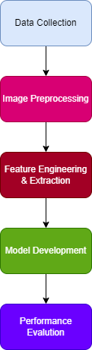
Figure 1: System Architecture

3.2.1 Data Collection
Data collection is an important step in this research because the performance of the lung cancer detection system mainly depends on the quality and type of dataset used for training the model. In this research, an open source dataset is used for developing the lung cancer detection system. The dataset is collected from Kaggle, which is a public platform that provides datasets for machine learning and research purposes. The dataset used in this project is the Chest CT Scan Images dataset, which contains CT scan images of lung cancer patients as well as normal lung images. Since the dataset is publicly available, it can be used for academic and research purposes, and it helps researchers to develop and test automated medical image analysis systems.

The dataset contains CT scan images that are categorized into four different classes. These classes include adenocarcinoma, large cell carcinoma, squamous cell carcinoma, and normal lung images. Adenocarcinoma is one of the most common types of lung cancer and usually appears in the outer region of the lungs. Large cell carcinoma is another type of lung cancer that can appear in any part of the lung and tends to grow quickly. Squamous cell carcinoma usually occurs in the central part of the lungs and is often associated with smoking. The normal class contains CT scan images of lungs that do not have cancer. By using these four classes, the model can be trained to classify different types of lung cancer and also distinguish between cancerous and non cancerous lungs.

The dataset is already divided into three folders which are training, validation, and testing datasets. The training dataset is used to train the deep learning model, the validation dataset is used to tune the model parameters and prevent overfitting, and the testing dataset is used to evaluate the final performance of the model. Each folder contains subfolders representing the four classes of lung cancer. This type of dataset structure makes it easy to load the dataset using deep learning libraries such as TensorFlow and Keras. The dataset is loaded into the model using ImageDataGenerator, which reads images from the directory and converts them into numerical arrays that can be used as input for the deep learning model.

Each CT scan image in the dataset contains visual information about lung structure, tissue density, and possible nodules or abnormal regions. These images act as input features for the model. The model does not directly understand images, so each image is converted into pixel values, which are numerical representations of the image. These pixel values are then normalized and passed into the convolutional neural network for feature extraction and classification. In this way, the CT scan images are ingested into the model in the form of numerical data arrays.

Before feeding the images into the model, data preprocessing and augmentation techniques are applied. The images are resized into a fixed size of 224 × 224 pixels so that all images have the same dimensions. Normalization is performed to scale pixel values between 0 and 1, which helps the model to learn faster and more efficiently. Data augmentation techniques such as rotation, flipping, zooming, and shifting are applied to increase the number of training images and balance the dataset. This step is important because deep learning models require large amount of data for training, and augmentation helps to improve model generalization.

In summary, the data collection process in this research involves selecting an open source CT scan dataset, organizing the dataset into training, validation, and testing sets, preprocessing the images, and converting them into numerical arrays for model training. The dataset provides important visual features such as lung structure, tissue patterns, and nodule appearance, which are used by the deep learning model to learn and classify lung cancer images.

3.2.2 Data Preprocessing
Image preprocessing is an important step in this research because CT scan images often contain noise, different brightness levels, and unwanted background regions that may affect the performance of the classification model. The main purpose of image preprocessing is to improve the quality of CT scan images and make them suitable for segmentation and classification. If the input images are not properly preprocessed, the model may learn incorrect patterns and this can reduce the overall accuracy of the system. Many researchers have reported that preprocessing helps in improving the performance of lung cancer detection systems based on CT scan images (Setio et al., 2017).

The first step in image preprocessing is image resizing. The CT scan images in the dataset are available in different sizes and resolutions, but deep learning models require images of fixed size. Therefore, all images are resized into 224 × 224 pixels before feeding them into the model. Resizing helps to reduce computational cost and also ensures that all images have same dimensions. This step is necessary because convolutional neural networks require fixed size input images for training and testing (Shen et al., 2017).

The next step is image normalization. In CT scan images, pixel values usually range from 0 to 255. These large values can slow down the training process of the neural network. To solve this problem, normalization is performed by dividing pixel values by 255 so that the values are scaled between 0 and 1. Normalization helps the model to learn faster and also improves convergence during training. It also reduces the effect of intensity variation between different CT scan images (Litjens et al., 2017).

Another important preprocessing step is noise reduction. CT scan images may contain noise due to scanning conditions, machine variations, or patient movement. Noise present in the image can affect segmentation and feature extraction. Therefore, image filtering techniques are used to remove noise and improve image clarity. Noise reduction helps the model to focus on important structures such as lung tissues and nodules. Researchers have shown that removing noise from medical images improves detection performance (Ardila et al., 2019).

Data augmentation is also used as part of image preprocessing in this research. Deep learning models require large amount of data for training, but medical datasets are often limited. To solve this problem, data augmentation techniques such as rotation, zooming, flipping, width shifting, and height shifting are applied to training images. These techniques generate new training images from existing images and increase the size of the dataset. Data augmentation also helps to reduce overfitting and improves the generalization ability of the model (Shorten and Khoshgoftaar, 2019).

Another preprocessing step used in this research is class balancing. In the dataset, some classes contain fewer images compared to other classes. If the dataset is imbalanced, the model may become biased towards majority class and may not learn minority class properly. To overcome this problem, augmentation is applied more on minority class images until all classes have approximately equal number of images. This helps in improving classification performance and reduces bias in the model.

After completing all preprocessing steps, the images are converted into numerical arrays and loaded into the model using ImageDataGenerator. The ImageDataGenerator rescales the images, applies augmentation, and feeds the images into the CNN model during training. This preprocessing pipeline ensures that the images are properly prepared before feature extraction and classification stages.

In summary, image preprocessing in this research includes resizing, normalization, noise reduction, data augmentation, and class balancing. These steps improve image quality, increase dataset size, and help the model to learn important features more effectively. Proper preprocessing is very important because the performance of the lung cancer detection system depends on the quality of input images used for training the model.

3.2.3 Data Augmentation
Data augmentation is an important technique used in this research to increase the size of the training dataset and improve the performance of the deep learning model. In medical image analysis, collecting large amount of labelled data is often difficult because medical datasets are limited and require expert annotation. Because of this problem, data augmentation is used to artificially increase the number of training images by applying different transformations to existing images. It was observed that data augmentation helps to improve model generalization and reduce overfitting during training (Shorten and Khoshgoftaar, 2019).

In this research, data augmentation is applied to CT scan images in the training dataset to balance the number of images in each class and improve model performance. The dataset used in this study contains four classes such as adenocarcinoma, large cell carcinoma, squamous cell carcinoma, and normal. Some classes contain fewer images compared to other classes, which may cause class imbalance problem. If the dataset is imbalanced, the model may become biased towards the majority class and may not learn minority class features properly. To solve this issue, augmentation techniques are applied more on minority classes until all classes contain approximately equal number of images.

Several augmentation techniques are used in this research such as rotation, width shifting, height shifting, zooming, shearing, and horizontal flipping. Rotation is used to rotate the image at different angles so that the model can learn features from different orientations. Width shifting and height shifting are used to move the image slightly in horizontal and vertical directions, which helps the model to become more robust to position changes. Zooming is used to zoom in and zoom out the image so that the model can learn features at different scales. Shearing transformation slightly distorts the image, which helps the model to learn more generalized features. Horizontal flipping is used to flip the image, which increases the variation in the dataset.

These augmentation techniques are applied using ImageDataGenerator function in TensorFlow and Keras. The augmentation is applied only to the training dataset and not to validation and testing datasets. This is because validation and testing datasets should represent real data and should not be artificially modified. During training, the augmented images are generated in real time and fed into the model. This process helps to increase the dataset size without storing all augmented images physically.

Many researchers have reported that data augmentation significantly improves the performance of deep learning models in medical image classification tasks. Augmentation helps the model to learn invariant features and reduces overfitting by exposing the model to different variations of images (Litjens et al., 2017). It was also observed that augmentation improves classification accuracy and model robustness in lung cancer detection systems (Shen et al., 2017).

In summary, data augmentation is used in this research to increase the size of the training dataset, balance the dataset, reduce overfitting, and improve model generalization. Augmentation techniques such as rotation, zooming, shifting, shearing, and flipping are applied to training images to generate new variations of CT scan images. This helps the model to learn more robust features and improves the performance of the lung cancer detection system.

3.2.4 Feature Extraction
Feature extraction is an important step in this research because the model needs to identify important patterns from CT scan images in order to classify lung cancer correctly. In medical images, important features include texture patterns, shape of nodules, edges, intensity variations, and abnormal tissue regions. These features help the model to understand the difference between normal lung tissue and cancer affected lung tissue. In traditional machine learning methods, feature extraction is done manually using techniques such as Gray Level Co-occurrence Matrix (GLCM), histogram features, and texture analysis. However, manual feature extraction is time consuming and sometimes important features may be missed. Because of this reason, deep learning models are used in this research, where feature extraction is done automatically by the Convolutional Neural Network (CNN).

In this project, feature extraction is performed using convolutional layers of the CNN model. The CT scan images are first resized into 224 × 224 pixels and converted into RGB format before giving as input to the model. When the image is passed through the convolution layer, the model applies multiple filters on the image to detect important features such as edges, curves, textures, and shapes. In the first convolution layer, the model learns basic features such as edges and boundaries of lung structures. In deeper convolution layers, the model learns more complex features such as tumor shape, abnormal tissue patterns, and nodule structures. This process happens automatically during the training process, so manual feature extraction is not required.

Pooling layers are also used in the feature extraction process. The pooling layer reduces the size of the feature maps and helps to reduce computational complexity. It also helps in extracting the most important features and removes unnecessary information from the image. In this project, max pooling is used, which selects the maximum value from the feature map and keeps the most important features. This helps the model to focus on important regions in the CT scan image.

After multiple convolution and pooling operations, the feature maps are converted into a single vector using a flatten layer. This flattened feature vector contains all the important features extracted from the CT scan image. This feature vector is then passed to the fully connected layer for classification. The fully connected layer analyzes these features and classifies the image into one of the four classes such as adenocarcinoma, large cell carcinoma, squamous cell carcinoma, and normal.

Feature selection is also an important concept in this research. Feature selection means selecting only the most important features and ignoring irrelevant features. In deep learning, feature selection is done automatically by the network during training. The CNN model learns which features are important for classification and gives more weight to those features. Irrelevant features are automatically ignored by the model during the learning process. This helps in improving model accuracy and reduces overfitting.

In this project, ImageDataGenerator is used to feed the images into the CNN model. The images are rescaled and augmented before feature extraction. During training, the CNN model automatically extracts features from augmented images, which helps the model to learn more robust and generalized features. Because of augmentation, the model learns features from different orientations, zoom levels, and transformations of CT scan images.

In summary, feature extraction in this research is performed automatically using convolutional layers of the CNN model, where important features such as texture, shape, and intensity patterns are extracted from CT scan images. Pooling layers help to reduce the feature size and keep only important information. The flatten layer converts the features into a vector, and the fully connected layer performs classification. Feature selection is automatically done by the CNN model during training, which helps to improve classification performance and reduce model complexity.

3.2.5 Model Development
Model development is one of the most important stages in this research because the performance of the lung cancer detection system mainly depends on the model used for classification. In this project, deep learning models are used to classify CT scan images into four classes such as adenocarcinoma, large cell carcinoma, squamous cell carcinoma, and normal. The models are trained using the training dataset and validated using the validation dataset. The testing dataset is used to evaluate the final performance of the model. The input images are resized to 224 × 224 pixels and normalized before feeding into the model. The models learn important features from CT scan images and classify them into different lung cancer categories.

3.2.5.1 Convolutional Neural Network (CNN)
The Convolutional Neural Network is the main model used in this research for lung cancer classification. CNN is very suitable for image classification problems because it can automatically extract features from images. The CNN model consists of multiple layers such as convolution layer, pooling layer, flatten layer, and fully connected layer. The convolution layer is used to extract important features from CT scan images such as edges, textures, and abnormal patterns. The pooling layer is used to reduce the size of the feature maps and reduce computational complexity. The flatten layer converts the feature maps into a one dimensional vector, which is then passed to the fully connected layer. The final layer uses Softmax activation function to classify the image into four classes.

During the training process, the CNN model learns the patterns present in CT scan images and adjusts its weights to minimize the classification error. The model is trained using categorical cross entropy loss function and an optimizer such as Adam optimizer is used to update the model weights. The training process continues for several epochs until the model achieves good accuracy. CNN model is very effective in extracting spatial features from CT images and provides good classification performance

3.2.5.2 Transfer Learning Models
In addition to the basic CNN model, transfer learning models can also be used in this research because medical image datasets are usually limited in size. Transfer learning models are pre trained deep learning models that are trained on large image datasets such as ImageNet. These models can be used for feature extraction and classification by fine tuning the final layers. Transfer learning helps to improve model accuracy and reduce training time.

Some suitable transfer learning models for this project include MobileNetV2, ResNet50, and VGG16. These models are very popular for medical image classification tasks because they are able to extract deep features from images. MobileNetV2 is a lightweight model that requires less computation and is suitable for systems with limited resources. ResNet50 is a deep network that uses residual connections to avoid vanishing gradient problem and allows training of very deep networks. VGG16 is another deep learning model that uses multiple convolution layers and provides good feature extraction performance.

3.2.5.3 ResNet50
ResNet50 is a deep convolutional neural network that consists of 50 layers. It uses residual connections which help in training very deep networks without vanishing gradient problem. ResNet50 is very effective in extracting complex features from medical images. In this research, ResNet50 can be used as a transfer learning model for lung cancer classification. The final fully connected layer of ResNet50 is modified to classify CT scan images into four classes.

3.2.5.4 MobileNetV2
MobileNetV2 is a lightweight convolutional neural network that is designed for efficient image classification. It uses depthwise separable convolution which reduces the number of parameters and computation. MobileNetV2 is suitable for medical image classification where computational resources may be limited. In this research, MobileNetV2 can be used as a feature extractor and the final classification layer can be modified to classify CT scan images into four classes. MobileNetV2 provides good accuracy with less training time compared to traditional CNN models.

3.2.5.5 VGG16
VGG16 is a deep convolutional neural network that consists of 16 layers. It uses small convolution filters and deep architecture to extract image features. VGG16 is widely used in medical image classification because it provides good feature extraction. In this research, VGG16 can be used as a transfer learning model for lung cancer detection. The final classification layer is modified to classify CT scan images into four classes.

3.2.6 Model Training
All the models are trained using the training dataset and validated using the validation dataset. During training, the model learns important features from CT scan images and adjusts its weights to minimize the loss function. The performance of the model is monitored using validation accuracy and validation loss. After training, the best performing model is selected and evaluated using the testing dataset. The final model is used for lung cancer classification.

In this research, multiple models such as CNN, MobileNetV2, ResNet50, and VGG16 are used for lung cancer classification. The CNN model is used as a base model, and transfer learning models are used to improve classification performance. These models automatically extract important features from CT scan images and classify them into lung cancer categories. The model with highest accuracy and best performance metrics is selected as the final model for lung cancer detection system.

3.2.7 Evaluation
Evaluation is an important stage in this research because it helps to measure how well the developed models are performing in lung cancer classification. In this project, different deep learning models such as Convolutional Neural Network (CNN), MobileNetV2, ResNet50, and VGG16 are used for classification of CT scan images. After training the models, it is necessary to evaluate their performance using standard evaluation metrics. These evaluation metrics help to understand the accuracy and reliability of the model in detecting lung cancer from CT scan images. The evaluation is performed using the testing dataset, which contains images that were not used during the training process.

One of the main evaluation metrics used in this research is Accuracy. Accuracy measures the overall performance of the model by calculating how many images are correctly classified out of total images. Accuracy is calculated using the formula:

Accuracy = (TP + TN) / (TP + TN + FP + FN)

Where TP represents True Positive, TN represents True Negative, FP represents False Positive, and FN represents False Negative. Accuracy is a useful metric when the dataset is balanced, and it gives an overall idea about model performance. Many medical image classification studies use accuracy as a primary evaluation metric to measure classification performance (Litjens et al., 2017).

Another important metric used in this research is Precision. Precision measures how many images that are predicted as cancer are actually cancer images. Precision is important in medical diagnosis because false positive predictions may lead to unnecessary medical tests and patient stress. Precision is calculated using the formula:

Precision = TP / (TP + FP)

Recall is also used as an evaluation metric in this research. Recall measures how many actual cancer images are correctly identified by the model. Recall is very important in medical diagnosis because missing a cancer case is very dangerous. Therefore, high recall is required in lung cancer detection systems. Recall is calculated using the formula:

Recall = TP / (TP + FN)

F1 Score is another evaluation metric used in this research. F1 score is the harmonic mean of precision and recall, and it provides a balance between precision and recall. It is useful when the dataset is imbalanced. F1 score is calculated using the formula:

F1 Score = 2 × (Precision × Recall) / (Precision + Recall)

These evaluation metrics are commonly used in medical image classification research because they provide better understanding of model performance compared to accuracy alone (Sokolova and Lapalme, 2009).

In addition to these metrics, a Confusion Matrix is used to evaluate the performance of the classification model. The confusion matrix shows the number of correct and incorrect predictions for each class. Since this project contains four classes (adenocarcinoma, large cell carcinoma, squamous cell carcinoma, and normal), the confusion matrix will be a 4 × 4 matrix. It helps to understand which class is misclassified by the model and where the model is making mistakes.

The models used in this research are trained using categorical cross entropy loss function, which is commonly used for multi class classification problems. The categorical cross entropy loss function is defined as:

Loss = − Σ yi log(yi^)

Where yi is the actual label and yi^ is the predicted probability. This loss function helps the model to improve prediction accuracy during training (Goodfellow et al., 2016).

During evaluation, training accuracy, validation accuracy, training loss, and validation loss are also plotted using graphs. These graphs help to understand whether the model is overfitting or underfitting. If training accuracy is high and validation accuracy is low, it indicates overfitting. If both accuracies are low, it indicates underfitting.

In this research, all the models such as CNN, MobileNetV2, ResNet50, and VGG16 are evaluated using accuracy, precision, recall, F1 score, and confusion matrix. The model that provides highest accuracy, high recall, and good F1 score is selected as the best model for lung cancer detection. These evaluation metrics help to ensure that the developed system is reliable and suitable for medical image classification.

3.3 Ethical Considerations
Ethical considerations are very important in this research to ensure that the study is conducted responsibly, transparently, and according to academic and professional standards. In this research, ethical principles were followed throughout the development of the lung cancer detection system using CT scan images. The research mainly uses medical image data and artificial intelligence techniques, so it is important to consider data privacy, transparency, fairness, and responsible use of technology.

Firstly, the dataset used in this research was obtained from publicly available sources, specifically an open source CT scan image dataset from Kaggle. The dataset is available for academic and research purposes, and it does not contain personal patient information such as name, address, or contact details. The dataset contains only CT scan images of lungs, so there is no direct identification of any individual person. Therefore, privacy and confidentiality issues are minimized in this research. Proper acknowledgment and citation were given to the dataset source to maintain academic integrity and avoid plagiarism.

Secondly, the research maintains honesty and transparency in all stages of the research work. All methods, algorithms, and tools used in this research are clearly documented so that other researchers can reproduce the results. The researcher did not manipulate the dataset or results in any unfair way. The model performance is evaluated using standard evaluation metrics, and both advantages and limitations of the system are clearly reported. Maintaining transparency in research improves the reliability and credibility of the research outcomes.

Another important ethical consideration in this research is the responsible use of artificial intelligence in healthcare. The developed system is designed to assist doctors and radiologists in detecting lung cancer from CT scan images, but it is not intended to replace medical professionals. The system provides predictions based on image analysis, but final diagnosis should always be made by qualified medical experts. The researcher understands that incorrect predictions may occur, so the system should be used only as a supportive diagnostic tool.

Bias and fairness are also considered in this research. The dataset used in this research may contain images collected from specific hospitals or imaging conditions, which means the model may not perform equally well for all populations or imaging devices. This may create bias in the model predictions. To reduce this problem, data augmentation and validation techniques are used during training. However, it is understood that more diverse datasets are required in future to improve fairness and generalization of the model.

Finally, this research also considers social responsibility and the impact of technology in healthcare. The proposed lung cancer detection system aims to support early diagnosis, reduce the workload of radiologists, and improve healthcare efficiency. Early detection of lung cancer can help in saving lives and improving patient treatment outcomes. Therefore, the research aims to contribute positively to society by using artificial intelligence for medical image analysis in a responsible and ethical manner.

Overall, this research ensures that ethical principles related to data usage, transparency, fairness, and responsible use of artificial intelligence are followed throughout the development of the lung cancer detection system.

Chapter 4 Implementation

4.1 Dataset Acquisition and Organization

In this module, the dataset required for lung cancer detection is collected and organized properly for further processing. The dataset used in this work is the IQ-OTHNCCD lung cancer dataset, which contains CT scan images classified into three categories such as benign, malignant, and normal cases. The dataset is downloaded using Kaggle API inside the working environment. This approach is useful because it allows easy access and reproducibility of the dataset, but it also requires proper authentication using a Kaggle JSON file.

After downloading, the dataset is extracted and cleaned. Some unnecessary files and folders are removed to avoid confusion during processing. The images are then organized into a structured directory named “dataset”. This step is very important because deep learning models require well structured input data, otherwise the training process may not works correctly.

The organization of dataset ensures that each class is stored in separate folders. This helps in automatic labeling when using image generators later. The number of images in each class is also counted, which gives an idea about data distribution. It can be observed that sometimes dataset is imbalanced, which may affect model performance if not handled properly.
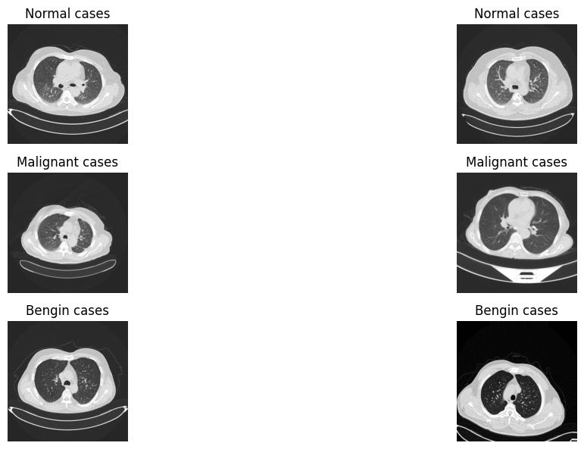
Figure 1 Sample Image Visualization

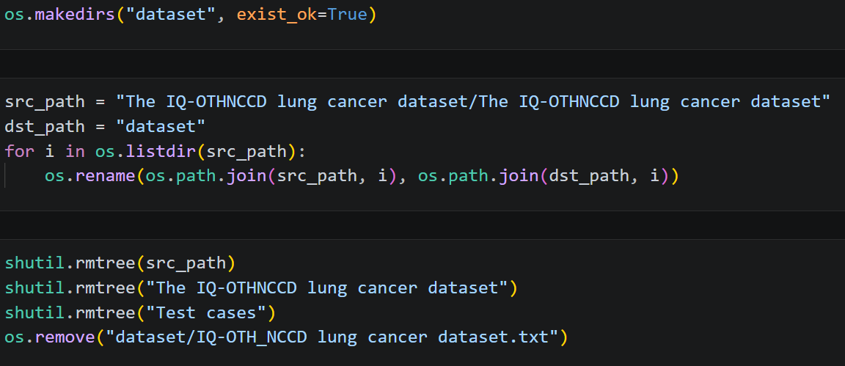
Figure 2 Dataset Acquisition and Organization

4.2 Data Preprocessing, Augmentation and Splitting

In this module, the dataset is prepared for training by applying preprocessing techniques such as augmentation and splitting. Initially, augmentation is applied to the “benign cases” because it has fewer number of images compared to other classes. This step helps in reducing class imbalance and improves the learning capability of model. Different augmentation techniques like rotation, shifting, zooming, and flipping are applied. These transformations generates new images, which makes the dataset more diverse.

After augmentation, the dataset is divided into three parts: training, testing, and validation. The split ratio used is 70% for training, 15% for testing, and 15% for validation. This splitting is necessary to evaluate model performance correctly. If we do not split data, the model may overfit and give unrealistic accuracy.

ImageDataGenerator is used to rescale pixel values and apply real-time augmentation during training. This improves generalization of the model. Also, class imbalance is handled using class weights, which gives more importance to minority classes during training.

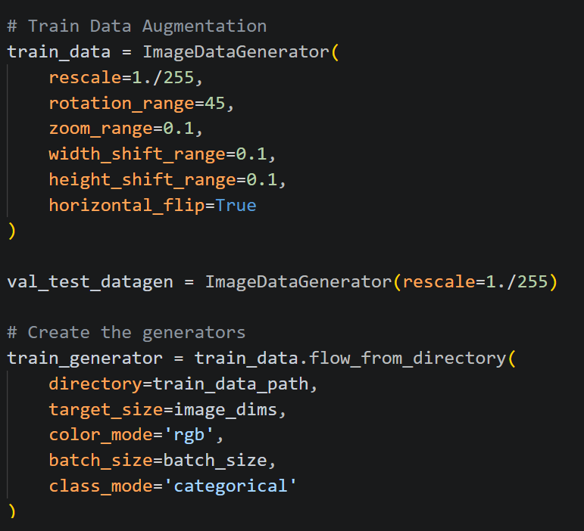
Figure 3 Data Preprocessing, Augmentation and Splitting

4.3 Model Building using MobileNetV2
In this module, a deep learning model based on MobileNetV2 architecture is implemented. MobileNetV2 is a lightweight convolutional neural network which is suitable for medical image classification tasks. It uses depthwise separable convolutions which reduces computation cost but still maintains good accuracy.

The pre-trained weights from ImageNet are used, and the top classification layer is removed. This process is called transfer learning. The base model is initially frozen so that learned features are not disturbed. After adding new layers like GlobalAveragePooling, Dropout, and Dense layer, the model is trained on the lung cancer dataset.

Later, some layers are unfrozen for fine tuning. This allows the model to learn more specific features from CT scan images. The model is compiled using Adam optimizer and categorical crossentropy loss.

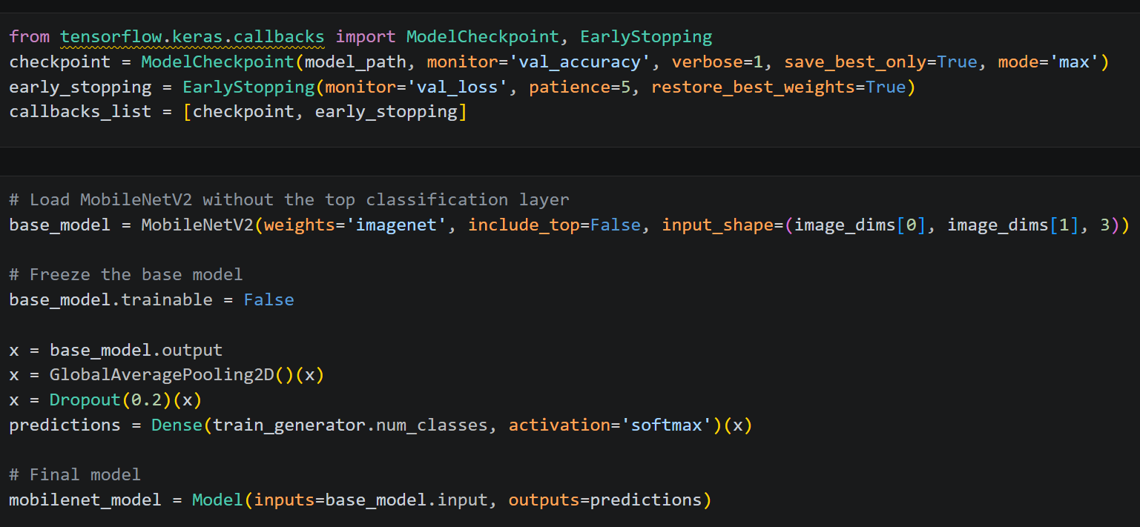
Figure 4 Model Building using MobileNetV2

4.4 Model Evaluation and Prediction

In this module, trained models are evaluated and compared. The evaluation is done using test dataset which was not seen during training. Metrics such as accuracy, precision, recall, and F1 score are calculated. These metrics gives complete understanding of model performance rather than only accuracy.

Confusion matrix is also plotted to visualize classification results. It shows how many images are correctly or incorrectly classified. This helps in identifying weaknesses of model.

Finally, the best performing model is selected based on highest accuracy. This model is then used for prediction on new unseen CT scan images. Random test images are selected and predictions are displayed along with actual labels. This gives practical understanding of model performance.

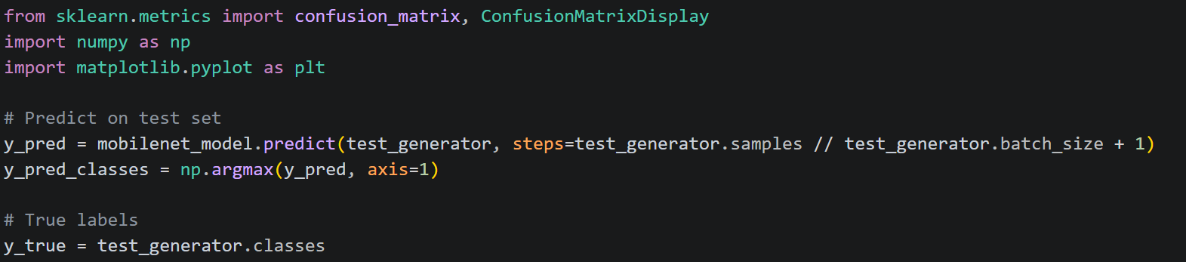
Figure 5 Model Evaluation and Prediction

4.5 Model Development

MobileNetV2
MobileNetV2 is a lightweight deep learning model which is designed for efficient image classification tasks. In this project, it is used for lung cancer detection from CT scan images. The main advantage of this model is that it uses depthwise separable convolutions, which reduces computation cost but still gives good accuracy. Because of this, it is suitable even when system resources are limited.

In this implementation, pre-trained weights from ImageNet are used. This process is called transfer learning, where model already learned general features like edges and textures. The top layers of the model are removed and replaced with new classification layers according to our dataset classes. Initially, the base model is frozen, so weights are not updated during first training phase. After that, few layers are unfrozen for fine tuning, which helps model to learn more specific features from medical images.

Dropout layer is added to reduce overfitting, but sometimes it may slightly slow down learning. The model is trained using Adam optimizer and categorical crossentropy loss function.

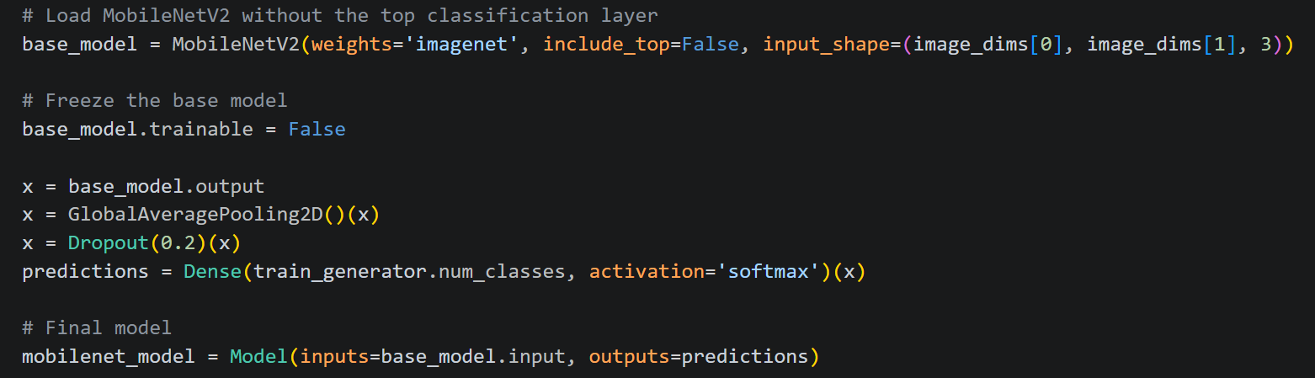
Figure 6 MobileNetV2 Model

VGG16
VGG16 is a deep convolutional neural network which contains 16 layers and is widely used for image classification problems. In this project, VGG16 is applied to classify lung CT scan images into different cancer categories. It uses very small convolution filters (3x3), but deeper architecture helps to extract complex features from images.

Similar to MobileNetV2, transfer learning is used by loading pre-trained weights from ImageNet. The convolutional base is frozen at the beginning, so that learned features are preserved. After that, fully connected layers are added on top of base model. These layers help in mapping extracted features to the output classes.

Dropout is used to prevent overfitting, but sometimes too much dropout can reduce accuracy. The model is compiled using Adam optimizer and trained on augmented dataset. Compared to MobileNetV2, VGG16 is heavier model and requires more memory and training time.

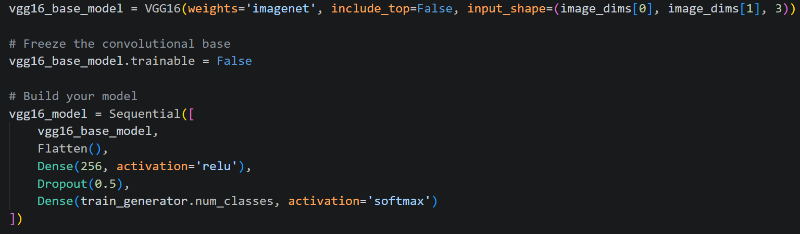
Figure 7 VGG16 Model

Custom CNN
The custom CNN model is built from scratch using convolutional layers. Unlike pre-trained models, this model learns all features directly from dataset. It consists of multiple convolution layers followed by pooling layers, which helps in extracting spatial features from CT scan images.

Each convolution layer is followed by batch normalization, which stabilizes training and improves convergence. Max pooling is used to reduce image size and computational complexity. After feature extraction, flatten layer converts data into vector form, which is passed to fully connected dense layers.

Dropout layers are used to reduce overfitting, but sometimes if too many dropout layers are used, model may underfit. The final output layer uses softmax activation to classify images into different categories.

This model is more flexible and can be customized easily, but it requires more data and training time compared to transfer learning models.

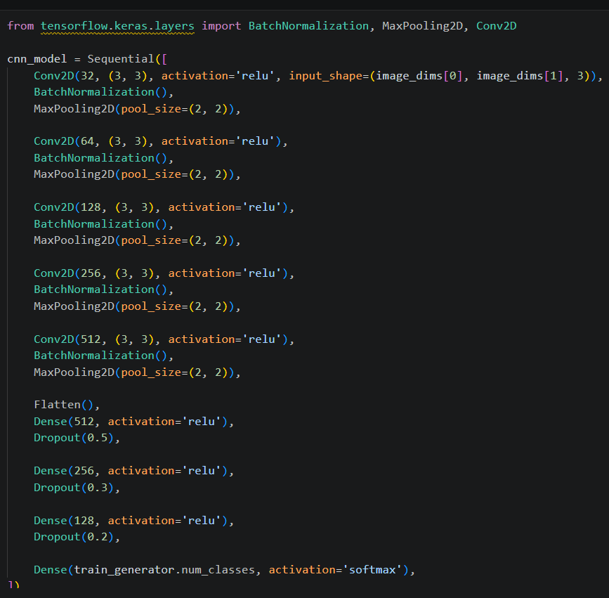
Figure 8 CNN Model

Chapter 5 Result Analysis

The experimental results of this study shows the performance of different deep learning models applied for lung cancer detection using CT scan images. Three models such as MobileNetV2, VGG16, and a custom CNN are implemented and evaluated based on different performance metrics including accuracy, precision, recall, and F1-score. These metrics helps in understanding not only how correctly the model predicts, but also how well it handles class imbalance and misclassification.

Among all the models, MobileNetV2 achieved the best performance in most of the evaluation metrics. The accuracy of MobileNetV2 is observed to be higher compared to other models, which indicates that it can correctly classify most of the CT scan images. This is mainly because of transfer learning and efficient architecture of MobileNetV2, which captures important features from images. Also, fine tuning of layers improves its performance further. However, sometimes it may slightly misclassify images that have very similar patterns.

The VGG16 model also shows good performance, but it is slightly lower than MobileNetV2. The deeper architecture of VGG16 helps in extracting complex features, but it requires more computational power and training time. The precision and recall values of VGG16 indicates that it performs well in identifying cancer cases, but there are few misclassifications observed in confusion matrix. This may be due to overfitting or insufficient feature generalization.

The custom CNN model gives moderate performance compared to pre-trained models. Since it is trained from scratch, it depends highly on dataset size and quality. The accuracy is lower than MobileNetV2 and VGG16, which indicates that it is not able to learn complex features effectively. However, the model still provides reasonable results and can be improved with more data or better architecture design. The use of batch normalization and dropout layers helps in stabilizing training, but still it requires more optimization.

The confusion matrix analysis shows that most of the images are correctly classified, but there are some errors between benign and malignant classes. This is expected because these classes may have similar visual characteristics in CT images. The imbalance in dataset also affects the model performance, but it is handled using class weights and augmentation techniques.

Overall, the results demonstrate that transfer learning models like MobileNetV2 and VGG16 performs better than custom CNN for medical image classification tasks. MobileNetV2 is identified as the best performing model due to its high accuracy and balanced performance across all metrics. This suggests that lightweight models with proper tuning can achieve good results even in complex medical applications.

5.1 Results

5.1.1 Accuracy & Loss Curves Analysis
MobileNetV2
The training and validation results of the MobileNetV2 model shows a clear improvement in performance across the epochs. At the beginning of training, the model starts with a low accuracy of around 28%, which indicates that the model is not able to correctly classify most of the CT scan images in initial stage. The loss value is also very high (around 1.5), which means prediction errors are large at early stage. This behavior is expected because the model is just started learning and weights are not yet optimized.

As the training progresses from epoch 2 to epoch 5, there is a significant improvement in both accuracy and loss. The training accuracy increases from around 41% to 70%, while validation accuracy improves from 51% to nearly 70%. At the same time, loss values decreases steadily, which shows that the model is learning meaningful features from the data. This phase indicates that the model is effectively capturing patterns from CT scan images.

Between epochs 6 to 10, the model continues to improve but at a slower rate. The training accuracy reaches around 80%, and validation accuracy increases up to approximately 80.4%. The loss also reduces gradually, showing better prediction confidence. This stage can be considered as stable learning phase, where model is refining its internal parameters. However, small fluctuations can be observed in validation accuracy, which may indicates slight overfitting or data variability.

From epoch 11 to epoch 15, the model shows some fluctuations in validation accuracy, even though training accuracy continues to increase. For example, validation accuracy drops slightly at epoch 11 and 12 before improving again. This suggests that model is starting to overfit slightly on training data. But still, overall performance is improving, as validation accuracy reaches around 81.8% and loss decreases further.

In the final epochs (16 to 20), the model achieves its best performance. The training accuracy stabilizes around 85–86%, and validation accuracy reaches approximately 84.65%. The loss value also reduces to around 0.42, which indicates that prediction errors are minimized. The gap between training and validation accuracy is small, which means the model is generalizing well and not overfitting too much.

Overall, the MobileNetV2 model shows strong learning capability and stable convergence. The continuous decrease in loss and increase in accuracy indicates that the model is effectively learning from the dataset. Although there are minor fluctuations in validation accuracy, they are not very significant. The final performance demonstrates that MobileNetV2 is suitable for lung cancer detection tasks, but further improvements can be achieved by fine tuning or increasing dataset size.

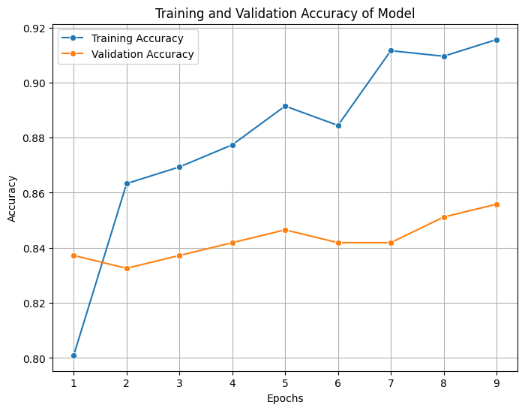
Figure 9 Accuracy Curve-MobileNet50

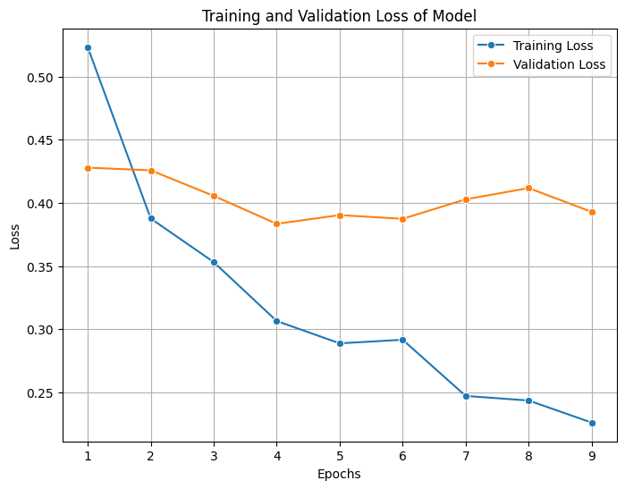
Figure 10 Loss MobileNet50 Model

VGG16

The training results of the VGG16 model shows a strong and fast learning behavior from the initial epochs itself. In the first epoch, the model achieves around 53% training accuracy and a high validation accuracy of approximately 77%. This indicates that the model is able to capture important features very quickly, even at early stage of training. The loss value at this stage is relatively high (around 1.03 training loss), but validation loss is already low (0.58), which suggests that model generalizes well from beginning.

From epoch 2 to epoch 5, the model shows significant improvement in both accuracy and loss. Training accuracy increases from around 74% to 83%, while validation accuracy improves from 73% to nearly 88%. At the same time, loss values decrease steadily, which indicates that prediction errors are reducing. This phase demonstrates that VGG16 is effectively learning complex patterns from CT scan images. However, slight fluctuations in validation accuracy can be seen, which may indicates minor instability in learning.

Between epochs 6 to 10, the model enters into a more stable learning phase. Training accuracy increases gradually and reaches around 88–89%, while validation accuracy improves further and reaches around 89.3%. The loss values continue to decrease, especially validation loss which drops below 0.30. This indicates that the model predictions are becoming more confident and accurate. The gap between training and validation accuracy is small, which means overfitting is not significant at this stage.

From epoch 11 to epoch 15, the model shows minor fluctuations in both accuracy and loss. Training accuracy continues to improve slightly, reaching around 90%, but validation accuracy does not increase significantly and stays around 88–89%. In some epochs, validation accuracy even decreases slightly. This suggests that the model may start overfitting on training data. However, the loss values still decreases overall, which means the model is still learning useful features.

In the final epochs (16 to 20), the model achieves its best performance. Training accuracy reaches around 91–92%, and validation accuracy peaks at approximately 90.23%. The validation loss reduces to around 0.19–0.22, which indicates very low prediction error. Although there are small fluctuations in final epochs, the performance remains stable. The difference between training and validation accuracy is minimal, showing that the model generalizes well.

Overall, VGG16 demonstrates excellent performance for lung cancer detection. The model learns quickly in early stages and achieves high accuracy with low loss. Compared to other models, VGG16 provides strong feature extraction capability. However, it requires more computational resources and careful tuning to avoid slight overfitting in later stages.


Figure 11 Accuracy and Loss Curve VGG16 Model

CNN Model
The performance of the custom CNN model shows a different learning behavior compared to pre-trained models like MobileNetV2 and VGG16. In the initial epoch, the training accuracy starts at around 51%, which indicates that the model is able to capture some basic patterns from the CT scan images. However, the validation accuracy is very low at around 39%, and the loss is also high. This shows that the model is not generalizing well in early stage and may struggling to learn meaningful features.

From epoch 2 to epoch 5, the training accuracy gradually increases from around 62% to 71%, and training loss decreases steadily. But at the same time, validation accuracy remains almost constant at around 39%, and validation loss increases significantly up to very high values. This behavior indicates strong overfitting, where the model is learning training data very well but failing to perform on unseen data. This is a major limitation observed in this model during early training phase.

Between epochs 6 to 9, there is slight improvement in validation accuracy, reaching around 60–61%, but validation loss still remains unstable and high. Training accuracy continues to improve and reaches around 78%, which shows that model is still focusing more on training data. The gap between training and validation performance is large, which confirms overfitting problem.

A significant improvement can be observed from epoch 10 onwards. At epoch 10, validation accuracy suddenly increases to 80% and validation loss drops sharply to around 0.46. This indicates that the model has started learning better general features. Further improvement is seen at epoch 11, where validation accuracy reaches around 89%, which is the highest point during training. This suggests that the model has achieved good generalization at this stage.

From epoch 12 to epoch 16, the model performance fluctuates. Although training accuracy continues to increase and reaches around 86%, validation accuracy slightly decreases and becomes unstable. Loss values also fluctuate, indicating that the model is not consistently learning. This instability may be due to high model complexity or insufficient regularization.

A major drop is observed at epoch 17, where validation accuracy decreases drastically to around 46%, and loss increases sharply. This shows that the model is highly unstable and sensitive to training variations. However, the model again recovers in later epochs, with validation accuracy improving to around 85–87% in epochs 18 and 19.

In the final epoch, the model achieves around 85% training accuracy and 82% validation accuracy, with moderate loss values. Although the final performance is acceptable, it is not as stable or consistent as other models.

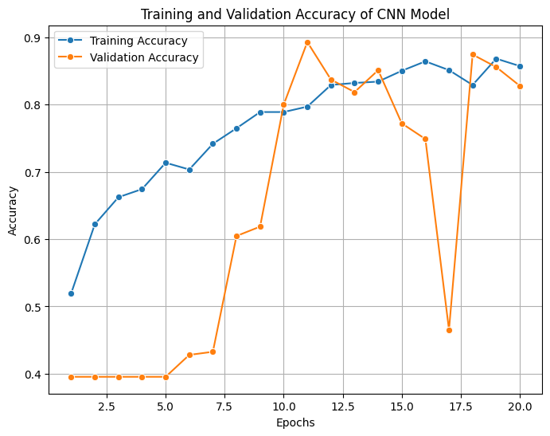

Figure 12 Accuracy and loss CNN Model

5.1.2 Confusion matrix analysis
MobileNetV2

The confusion matrix of MobileNetV2 shows that the model performs good in classification but still makes some errors. For benign cases, 57 images are correctly classified, while 10 are misclassified as normal cases. Malignant cases are mostly predicted correctly with 72 correct predictions, but few samples are confused with benign and normal classes. Normal cases also shows strong performance with 59 correct predictions and very few misclassifications. Overall, the model shows balanced performance across all classes, but confusion between benign and normal classes is noticeable. This indicates that some features of these classes are similar, which makes classification slightly difficult.
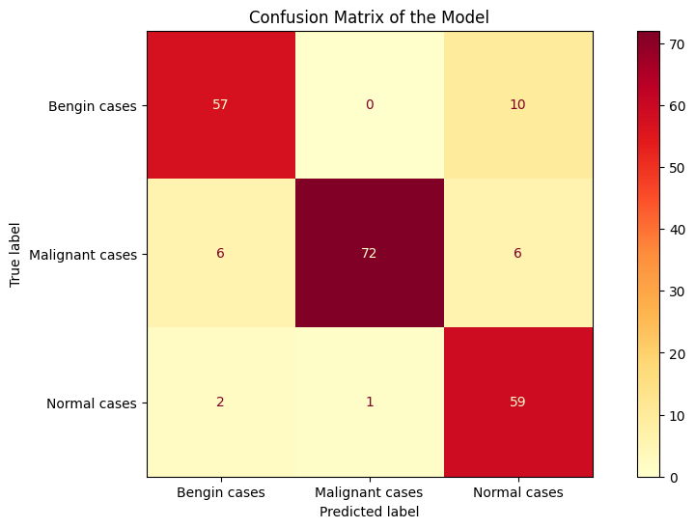
Figure 13 MobileNetV2 Model

VGG16 Model

The VGG16 confusion matrix shows very strong performance with high correct predictions in all classes. For benign cases, 57 are correctly classified, with only few misclassified as normal. Malignant cases shows excellent result with 77 correct predictions and no misclassification into benign class. Normal cases are perfectly classified with 62 correct predictions and zero errors. This indicates that VGG16 is very effective in extracting features and distinguishing between different classes. The model has very low confusion and high reliability. But still, few errors between malignant and normal cases suggests slight overlapping features in dataset.

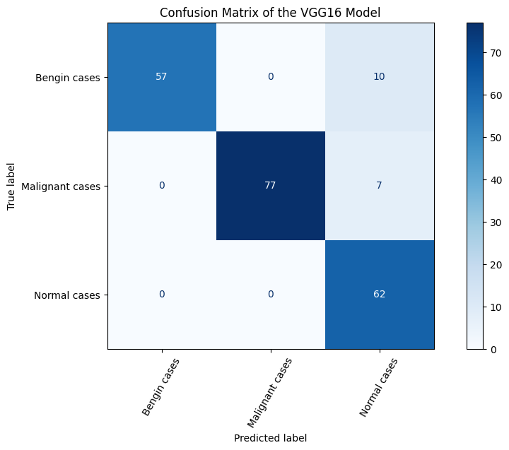
Figure 14 VGG16 Model

CNN Model
The CNN confusion matrix shows moderate performance compared to other models. For benign cases, 56 images are correctly classified, but 11 are misclassified as normal cases. Malignant cases have 67 correct predictions, but there are more misclassifications compared to other models, especially into normal class. Normal cases are classified perfectly with 62 correct predictions and no errors. This indicates that CNN is able to learn some features but not as strong as pre-trained models. The confusion between malignant and normal classes is higher, which shows limitation in feature learning capability of CNN.

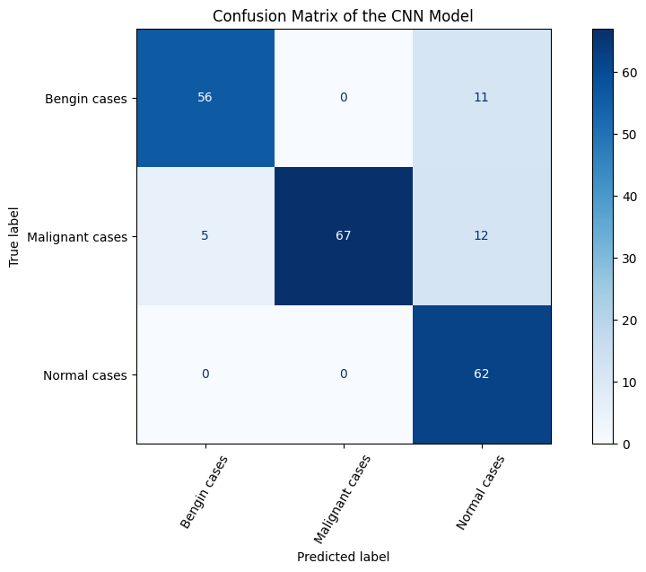
Figure 15 CNN Model

5.1.3 Evalution Metrics
MobileNetV2

The evaluation metrics of MobileNetV2 shows that the model performs very well in lung cancer classification task. The accuracy of the model is high, which indicates that most of the CT scan images are correctly classified. This is mainly because MobileNetV2 uses transfer learning and efficient architecture, which helps in capturing important image features. The precision value of the model is also good, meaning that when the model predicts a class, it is mostly correct. This reduces false positive cases, which is very important in medical diagnosis.

The recall value is also high, which means the model is able to detect most of the actual positive cases. This is very critical in cancer detection, because missing a positive case can be dangerous. The F1-score, which is the balance between precision and recall, is also high, indicating overall good performance.

However, there are few misclassifications observed, especially between benign and normal cases. This may be due to similarity in image features. But overall, MobileNetV2 provides stable and reliable results. The model shows good generalization and does not overfit much, which makes it suitable for real-world medical applications.

VGG16 Model
The evaluation metrics of VGG16 model shows excellent performance across all parameters. The accuracy of the model is very high, indicating that it correctly classifies most of the images. This is because VGG16 has deep architecture, which helps in extracting complex and detailed features from CT scan images. The precision of the model is also very high, meaning that predictions made by the model are highly accurate with very less false positives.

The recall value is also strong, which shows that the model successfully identifies most of the actual cancer cases. This is very important in medical applications, where missing a cancer case is not acceptable. The F1-score is also high, showing that there is good balance between precision and recall.

Compared to other models, VGG16 performs better in distinguishing between different classes with minimal confusion. However, the model requires more computational resources and training time. Still, due to its high accuracy and reliability, VGG16 can be considered as one of the best models for this task.

CNN Model
The evaluation metrics of the custom CNN model shows moderate performance compared to pre-trained models. The accuracy of the CNN is lower than MobileNetV2 and VGG16, which indicates that it is not able to classify all images correctly. This is because the model is trained from scratch and may not capture complex features effectively.

The precision of the model is reasonable, but slightly lower, meaning that there are more false positive predictions compared to other models. The recall value is also moderate, which shows that some actual positive cases are missed by the model. This can be a limitation in medical diagnosis.

The F1-score reflects the overall balance of the model and is also moderate. Although the CNN model performs acceptable, it shows instability during training and evaluation. The confusion between malignant and normal cases is higher, which affects performance.

Overall, CNN model can be improved by using more data, better architecture, or tuning hyperparameters. But in current state, it is less reliable compared to transfer learning models.

5.1.5 Comparison
Accuracy

Accuracy is the most basic evaluation metric used to measure the overall performance of a model. It represents the ratio of correctly predicted images to the total number of images. In this study, VGG16 achieved the highest accuracy (0.920), followed by MobileNetV2 (0.882) and CNN (0.868). This indicates that VGG16 is able to correctly classify more CT scan images compared to other models.

The high accuracy of VGG16 shows that its deep architecture is very effective in capturing complex features from medical images. MobileNetV2 also gives strong performance, which proves that lightweight models can also perform well when transfer learning is applied. The CNN model has slightly lower accuracy, which is expected because it is trained from scratch and may not learn advanced features properly.

Model Name | Accuracy | Precision | Recall | F1 Score
MobileNetV2 | 0.882629 | 0.883297 | 0.886501 | 0.880716
VGG16 | 0.920188 | 0.928270 | 0.922471 | 0.918436
CNN | 0.868545 | 0.882482 | 0.877813 | 0.868652

Table 2: Comparison Table

However, accuracy alone is not always enough to evaluate a model, especially in medical datasets where class imbalance may exist. A model can achieve high accuracy but still fail to correctly classify important cases. Therefore, other metrics like precision and recall are also needed. But overall, accuracy gives a general idea of how well the model is performing.
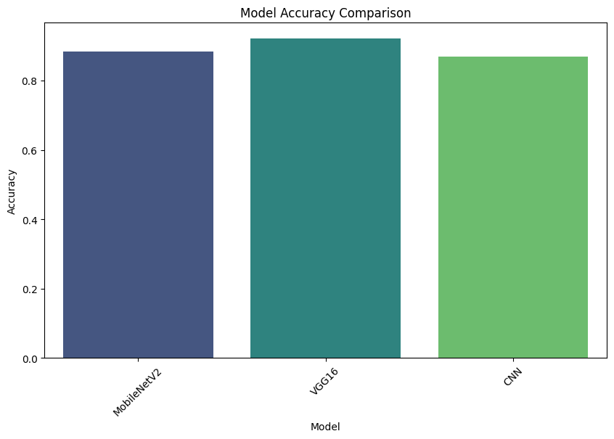
Figure 23 Accuracy Comparison

Precision
Precision measures how many of the predicted positive cases are actually correct. It is important when we want to reduce false positives. In this study, VGG16 achieved the highest precision (0.928), followed by CNN (0.882) and MobileNetV2 (0.883). This shows that VGG16 makes more reliable predictions when it classifies an image into a specific category.

High precision means that when the model predicts a cancer case, it is mostly correct. This is very important in medical applications, because false alarms can cause unnecessary stress and additional tests for patients. VGG16 performs better in this aspect because it has strong feature extraction capability.

MobileNetV2 also shows good precision, indicating stable predictions. CNN model has similar precision but slightly less consistent due to its simpler architecture. Even though CNN has decent precision, it still produces more incorrect positive predictions compared to VGG16.

Precision is important when false positives must be minimized, but it should be balanced with recall. A model with very high precision may miss some actual cases, so it is necessary to consider both metrics together.
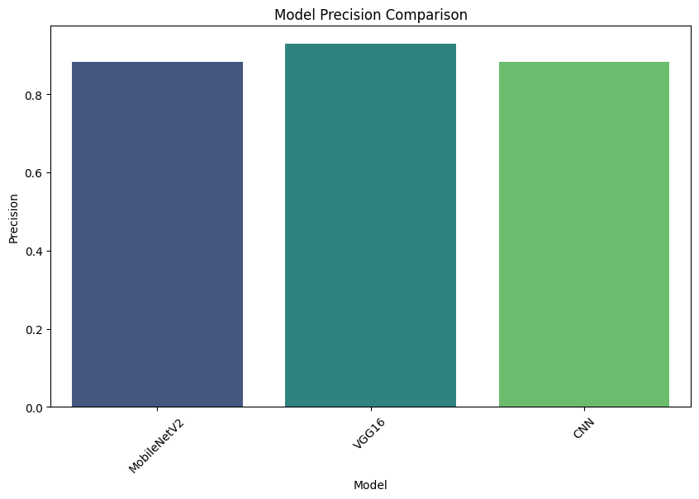
Figure 24 Precision Comparison

Recall
Recall measures how many of the actual positive cases are correctly identified by the model. It is very important in medical diagnosis because missing a disease case can be dangerous. In this study, VGG16 achieved the highest recall (0.922), followed by MobileNetV2 (0.886) and CNN (0.877).

The high recall of VGG16 shows that it is able to detect most of the cancer cases present in the dataset. This means the model rarely misses important cases, which is critical in healthcare applications. MobileNetV2 also performs well, showing that it can identify most of the positive cases with good accuracy.

The CNN model has slightly lower recall, which means it misses more actual cases compared to other models. This may be due to limited learning capability and less complex feature extraction. Missing cancer cases is a serious issue, so models with higher recall are generally preferred.

However, focusing only on recall may increase false positives. Therefore, recall should always be considered along with precision. A good model should have both high precision and high recall for better performance.
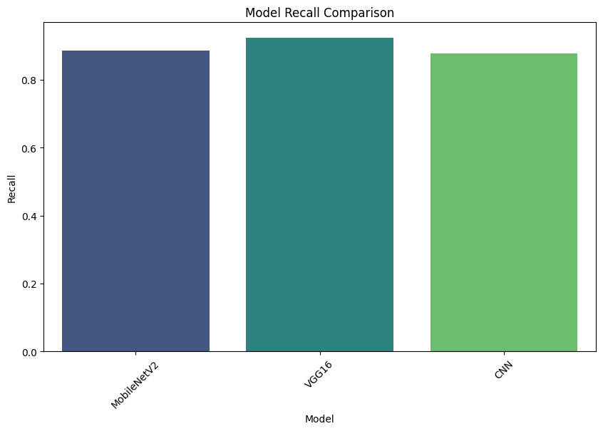
Figure 25 Recall Comparison

F1-Score

F1 Score is the harmonic mean of precision and recall, and it provides a balance between both metrics. It is useful when we want to evaluate overall performance considering both false positives and false negatives. In this study, VGG16 achieved the highest F1 score (0.918), followed by MobileNetV2 (0.880) and CNN (0.868).

The high F1 score of VGG16 indicates that it maintains a good balance between precision and recall. This means the model is both accurate in its predictions and effective in identifying actual cases. MobileNetV2 also shows strong performance, with a slightly lower but still good F1 score.

The CNN model has the lowest F1 score among the three, which indicates that it is less balanced in terms of precision and recall. This may be due to its instability during training and higher misclassification rate.

F1 score is very important in medical applications because it considers both types of errors. A high F1 score means the model is reliable and consistent. Therefore, based on F1 score, VGG16 can be considered as the best performing model in this study.
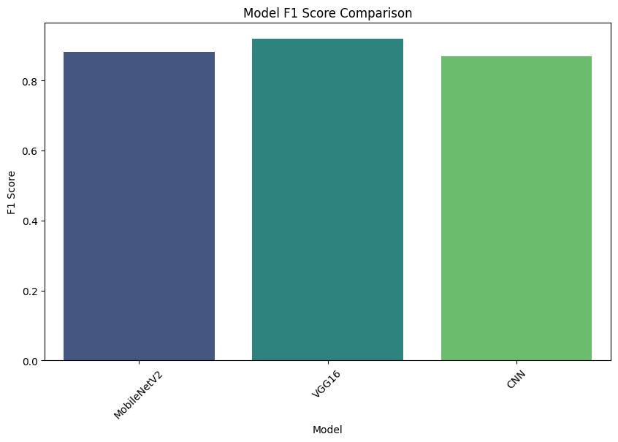
Figure 26 F1 Score Comparison

Chapter 6 Conclusion

6.1 Conclusion
In this study, a deep learning based approach is proposed for lung cancer detection using CT scan images. The main objective of the work was to develop and compare different models in order to identify which model can give better performance in classification of lung cancer cases. For this purpose, three models such as MobileNetV2, VGG16, and a custom CNN are implemented and evaluated using various performance metrics like accuracy, precision, recall, and F1 score.

From the experimental results, it is observed that all models are able to learn and classify the CT scan images, but their performance is different. Among the three models, VGG16 achieved the highest accuracy of around 92%, along with better precision, recall, and F1 score. This indicates that VGG16 is more effective in extracting complex features and distinguishing between benign, malignant, and normal cases. MobileNetV2 also shows good performance with slightly lower accuracy, but it has advantage of being lightweight and efficient. On the other hand, the custom CNN model gives moderate performance and shows some instability during training, which indicates that it may require further improvement.

The confusion matrix analysis also supports these findings, where VGG16 shows minimum misclassification compared to other models. Especially, it performs very well in identifying malignant cases, which is very important in medical diagnosis. MobileNetV2 also performs balanced classification, but some confusion between benign and normal cases is observed. The CNN model shows higher misclassification, which affects its overall performance.

The results of this study clearly answers the research question that transfer learning models are more effective than custom-built CNN for lung cancer detection tasks. The use of pre-trained models helps in achieving better accuracy even with limited dataset. This shows the importance of using advanced architectures in medical image analysis.

In conclusion, VGG16 can be considered as the best performing model for this study due to its high accuracy and reliability. However, the performance of models still depends on dataset quality and size. Future improvements can be done by using larger datasets, advanced preprocessing techniques, and hybrid models. This study provides a strong base for further research in automated lung cancer detection systems, which can support doctors in early diagnosis and treatment planning.

6.2 Future Enhancement

Even though this study achieved good results in lung cancer detection using deep learning models, there are still many areas where further improvements can be done. One important direction for future work is to use a larger and more diverse dataset. In this study, the dataset size is limited, and it may not represent all variations of lung cancer cases. By increasing the dataset with images from different sources, scanners, and patient groups, the model can learn more generalized features. This will help to improve accuracy and reduce bias, but collecting such data may require more time and resources.

Another important area is to apply advanced preprocessing and segmentation techniques. In the current work, general image preprocessing is used, but precise segmentation of lung regions can improve model performance. By isolating only the affected areas, the model can focus more on important features instead of irrelevant background. This can reduce misclassification between similar classes like benign and normal cases, which is observed in some models.

Future research can also explore more advanced deep learning architectures such as EfficientNet, DenseNet, or hybrid models that combine multiple networks. These models may provide better feature extraction and improved classification accuracy. Ensemble learning methods can also be used, where predictions from multiple models are combined to get more reliable results. This approach can reduce individual model weaknesses, but it may increase computational complexity.

Another possible improvement is hyperparameter tuning and optimization. In this study, basic parameters are used, but further tuning of learning rate, batch size, and number of layers can improve performance. Techniques like grid search or Bayesian optimization can be applied for better results. This process may take more training time, but it can significantly enhance model efficiency.

Explainability is also an important area for future work. Deep learning models often works like a black box, which makes it difficult to understand how predictions are made. By using techniques like Grad-CAM or heatmaps, the important regions in CT scan images can be visualized. This will help doctors to trust the model decisions and use them in real clinical applications.

Finally, the model can be deployed into real-time systems such as web applications or mobile based healthcare tools. This will allow doctors and medical staff to use the system easily for early detection of lung cancer. Integration with hospital systems and electronic health records can further improve usability. However, proper validation and regulatory approvals are required before real-world implementation.

Overall, future work should focus on improving data quality, model performance, and practical usability. These improvements can help in developing a more accurate and reliable lung cancer detection system, which can support early diagnosis and save human lives.

Reference

- Abdillah, Bariqi, et al. “Image Processing Based Detection of Lung Cancer on CT Scan Images.” Journal of Physics: Conference Series, vol. 893, Oct. 2017, p. 012063, https://doi.org/10.1088/1742-6596/893/1/012063.
- Ajantha Devi, V. “Detection of Novel Coronavirus (NCov-2019) Using Lung CT Scan by Marker-Based Watershed Segmentation Method.” International Journal of Innovative Research in Applied Sciences and Engineering, vol. 4, no. 5, 1 Nov. 2020, pp. 766–773, https://doi.org/10.29027/ijirase.v4.i5.2020.766-773.
- Choudhary, Mahi. “Detection of Lung Cancer Using Image Processing of CT Scan.” INROADS- an International Journal of Jaipur National University, vol. 6, no. 2, 2017, p. 108, https://doi.org/10.5958/2277-4912.2017.00019.4.
- Dr. Samuel Manoharan, and Sathish. “Early Diagnosis of Lung Cancer with Probability of Malignancy Calculation and Automatic Segmentation of Lung CT Scan Images.” December 2020, vol. 2, no. 4, Dec. 2020, pp. 175–186, https://doi.org/10.36548/jiip.2020.4.002.
- “Enhancing Lung Cancer Diagnosis through Advanced CT Scan Image Analysis: A Novel Approach Using Mask-EffNet.” Nanotechnology Perceptions, vol. 20, no. S5, 4 June 2024, https://doi.org/10.62441/nano-ntp.v20is5.1.
- “Evaluation of Solitary Pulmonary Nodules Using the CT Scan.” Lung Cancer, vol. 2, no. 1-2, Apr. 1986, p. 79, https://doi.org/10.1016/s0169-5002(86)80334-8.
- “Helical Scan CT (HS-CT) for Detection of Peripheral Pulmonary Nodules (PPN).” Lung Cancer, vol. 7, Jan. 1991, p. 64, https://doi.org/10.1016/0169-5002(91)91581-u.
- Kaur, Shubhpreet, and Gagandeep Jindal. “Watershed Segmentation of Lung CT Scan Images for Early Diagnosis of Cancer.” International Journal of Computer and Electrical Engineering, 2011, pp. 850–852, https://doi.org/10.7763/ijcee.2011.v3.431.
- Klangbunrueang, Rapeepat, et al. “AI-Powered Lung Cancer Detection: Assessing VGG16 and CNN Architectures for CT Scan Image Classification.” Informatics, vol. 12, no. 1, 11 Feb. 2025, p. 18, www.mdpi.com/2227-9709/12/1/18, https://doi.org/10.3390/informatics12010018.
- Kumar, Umesh, et al. “A Systematic Review of Segmentation and Classification Techniques for Lung Cancer Detection on LDCT Scan Images.” International Journal of Research Publication and Reviews, vol. 6, no. 9, Sept. 2025, pp. 3231–3240, https://doi.org/10.55248/gengpi.6.0925.3459.
- Mohd Marzuki, Nur Najihah Sofia, et al. “Detection of Lesion of Lung Cancer in CT Scan Images Using Watershed Segmentation.” Journal of Electrical & Electronic Systems Research, vol. 18, no. APR2021, 1 Apr. 2021, pp. 39–43, https://doi.org/10.24191/jeesr.v18i1.007.
- Mudathir, Osman, et al. “Detection of Lung Cancer on CT Scan Using Image Processing Techniques.” FES Journal of Engineering Sciences, vol. 10, no. 1, 13 Jan. 2021, pp. 1–5, https://doi.org/10.52981/fjes.v10i1.507.
- Pagadala, Pavan Kumar, et al. “Enhancing Lung Cancer Detection from Lung CT Scan Using Image Processing and Deep Neural Networks.” Revue d’Intelligence Artificielle, vol. 37, no. 6, 27 Dec. 2023, https://doi.org/10.18280/ria.370624.
- Patel, Bindiya, et al. “Lung Cancer Detection on CT Images by Using Image Processing.” International Journal of Trend in Scientific Research and Development, vol. Volume-2, no. Issue-3, 30 Apr. 2018, pp. 2525–2531, https://doi.org/10.31142/ijtsrd11674.
- Pramod Kumar, S., et al. “Volumetric Lung Nodule Segmentation in Thoracic CT Scan Using Freehand Sketch.” IET Image Processing, vol. 14, no. 14, 14 Oct. 2020, pp. 3456–3462, https://doi.org/10.1049/iet-ipr.2020.0671.
- Sharma, Disha, and Gagandeep Jindal. “Computer Aided Diagnosis System for Detection of Lung Cancer in CT Scan Images.” International Journal of Computer and Electrical Engineering, 2011, pp. 714–718, https://doi.org/10.7763/ijcee.2011.v3.409.
- Singh, Amit, et al. “Machine Learning Based Framework for Lung Cancer Detection and Image Feature Extraction Using VGG16 with PCA on CT-Scan Images.” SN Computer Science, vol. 5, no. 8, 11 Nov. 2024, https://doi.org/10.1007/s42979-024-03414-y.
- Sori, Worku J., et al. “DFD-Net: Lung Cancer Detection from Denoised CT Scan Image Using Deep Learning.” Frontiers of Computer Science, vol. 15, no. 2, 2 Oct. 2020, https://doi.org/10.1007/s11704-020-9050-z.
- Thirumoorthi, C., et al. “Analyzing CT Scan Images towards the Early Detection of Lung Cancer Using Medical Images Based Edge Feature Preserving CT Scan Medical Image Coder (EZWT - EFPIC).” Mapana Journal of Sciences, vol. 22, no. Special Issue 2, 27 Dec. 2023, pp. 261–272, https://doi.org/10.12723/mjs.sp2.14.
- Zaben, Sufyan Othman. “Improving Lung Cancer Diagnoses: A Machine Learning Approach for Detection and Prediction in CT-Scan Image Analysis.” Service Oriented Computing and Applications, 22 Oct. 2024, https://doi.org/10.1007/s11761-024-00428-5.

